# Response of kelp forest communities along the coast of Washington, USA to the 2014-2016 marine heatwave and sea star wasting disease

Tolimieri1, Nick

Shelton1, Andrew

Samhouri1, Jameal

Harvey1, Chris,

Feist1 Blake,

Williams2, Greg

Andrews1, Kelly

Frick3, Kinsey

Lonhart4, Steve

Sullaway5, Genoa

Liu1, Owen

Berry6, Hellen

Waddell7, Jenny

1Conservation Biology Division, Northwest Fisheries Science Center, NOAA Fisheries, 2725 Montlake Blvd E, Seattle WA 98125

2 Pacific States Marine Fisheries Commission, under contract to Conservation Biology Division, Northwest Fisheries Science Center, National Marine Fisheries Service, National Oceanic and Atmospheric Administration, 2725 Montlake Blvd E., Seattle, WA 98112, USA.

3Fish Ecology Division, Northwest Fisheries Science Center, NOAA Fisheries, 2725 Montlake Blvd E, Seattle WA 98125

4Monterey Bay National Marine Sanctuary, National Ocean Service, National Oceanic and Atmospheric Administration, 110 McAllister Way, Santa Cruz, CA 95060

5College of Fisheries and Ocean Sciences, University of Alaska Fairbanks, 17101 Point Lena Loop Road Juneau, AK 99801

6Aquatic Resources Division, Washington Department of Natural Resources, 1111 Washington St SE, Olympia, WA 98504-7027

7Olympic Coast National Marine Sanctuary, National Ocean Service, National Oceanic and Atmospheric Administration, 115 E. Railroad Ave. Suite #301, Port Angeles, WA 98362, USA

Corresponding author: nick.tolimieri@noaa.gov

# Abstract

We examined the response of kelp communities at five sites along the Olympic Coast of Washington State, USA to the recent perturbations stemming from anomalous warm water events (e.g., the 2014-2016 marine heatwave) and sea star wasting disease using a combination of SCUBA surveys (2015-2021) augmented by longer-term data on kelp canopy cover and sea surface temperature (SST). Anomalously warm SST in 2013 and 2014 corresponded with a loss of approximately 50% of the canopy cover of two kelps, *Macrocystis pyrifera* and *Nereocystis luetkeana*, in 2014, however, canopy cover for both kelp species rapidly recovered to earlier levels, and stipe density increased after 2015. Following the perturbations, there was also a 163-fold increase in the density of purple sea urchins (*Strongylocentrotus purpuratus*), but this increase did not begin until 2017 and peaked in 2019, well after the onset of warming, before declining again in 2021. We did not see evidence indicating the recovery of sea star populations, and the abundance of several species, including the sunflower star Pycnopodia helianthoides, continued to decline. . Multivariate analyses found that variation among sites explained the majority of variation in assemblage structure for three guilds: kelps, macroinvertebrates, and fishes, while yearly variation explained most of the variability in the abundance of rockfish (*Sebastes* spp.) juveniles. We did not see strong relationships between urchins and kelp that would suggest top-down impacts of urchins on kelp abundance, except at a small spatial scale at one site. We did find that juvenile rockfishes were more likely to occur where kelp stipe density was high. Kelp forests on the Washington coast appear to have been largely resilient to the effects of the warm SST and low sea star densities because absolute increase in SST was low or moderate compared to other regions along the coast, resulting in lower canopy loss, and because urchin abundance did not increase until after kelp had recovered, allowing kelp to win the race to recovery.

# 

# Introduction

A rich body of literature and observation indicates that kelp forests—iconic, highly productive nearshore habitats in temperate waters throughout the world’s oceans—are susceptible to state changes from kelp forest to urchin barren habitat (Rogers-Bennett and Catton 2019, Beas-Luna et al. 2020b, Williams et al. 2021). These state changes can be precipitated by climate and oceanographic variability (Pearse and Hines 1987), or by trophic dynamics triggered by shifts in populations and behaviors of key consumers (Watson and Estes 2011, Feehan and Scheibling 2014, Shelton et al. 2018, Dunn et al. 2021). Such sudden changes pose a risk to the wide range of valuable ecosystem functions provided by kelp forests (Smith and Fox 2021), including habitat provisioning and enhanced productivity of nearshore food webs (Duggins et al. 1989, Smith and Fox 2021), support for highly diverse and complex food webs (Gabara et al. 2021), influence on sedimentation dynamics (Connell 2005), coastal protection from wave energy (Pinsky et al. 2013), and carbon sequestration and buffering against ocean acidification (Wilmers et al. 2012, Weigel and Pfister 2021, but see Gallagher et al. 2022). By fueling nearshore production and providing extensive adult and juvenile fish habitat, kelp forests also support diverse ecological communities (Graham 2004, Schiel and Foster 2015) and important commercial, recreational and subsistence fisheries for both fish and invertebrate species (Rogers-Bennett and Catton 2019). As many ecosystem-level perturbations are anticipated to intensify under scenarios of climate and ocean change (IPCC 2022), maintaining services from kelp forests requires regional mechanistic studies to understand dynamic community responses.

Kelp forests along the west coast of North America have experienced several major perturbations in the last decade. The northeast Pacific Ocean experienced a massive and prolonged marine heatwave (MHW), which began to develop in the southeast Gulf of Alaska in the boreal winter of 2013/2014, began to impact the nearshore in 2014 (hence our use of 2014 throughout as the start date), and persisted until 2016 (Bond et al. 2015, Jacox et al. 2018, Cheung and Frölicher 2020, Scannell et al. 2020). This MHW had profound effects on both the offshore and nearshore ecosystem (Cavole et al. 2016, Morgan et al. 2019, Sanford et al. 2019, Cheung and Frölicher 2020), including substantial loss of kelp in some areas (Cavanaugh et al. 2019, Beas-Luna et al. 2020b). The timing of when this 2014-2016 MHW impacted the nearshore environment varies with latitude, and subsequent MHWs followed in 2019, 2020, and 2021 (Bond et al. 2015, Scannell et al. 2020, Harvey et al. 2022). Additionally, beginning in 2013, sea star wasting disease (SSWD) decimated populations of at least 20 species of sea stars from California to Alaska (Hewson et al. 2014, Montecino-Latorre et al. 2016, Hewson et al. 2018, Hamilton et al. 2021). On the outer coast of Washington, *Pycnopodia helianthoides declined* by 75% prior to 2018 and had lost 99.6 % of its population by 2020 (Hamilton et al. 2021). Some areas also saw large increases in urchins, which are prolific grazers and capable of near-complete reduction of kelp stands to urchin barrens. As many of the hardest hit sea stars (e.g., *Pycnopodia helianthoides*) consume urchins, the die-off may have reduced top-down predation pressure on sea urchins. However, urchins follow well-documented boom-bust reproductive cycles (Pearse and Hines 1987, Uthicke et al. 2009), and the dramatic increase in purple urchin populations in the early 2010s, which is temporally and spatially disjunct along the northeastern Pacific, may be due to a combination of factors including a reduction in predators (sea stars, especially *Pycnopodia helianthoides*; Hamilton et al. 2021), a change in foraging behavior due to a SST-driven decrease in available drift kelp (Kriegisch et al. 2019), and a numeric increase due to successful recruitment and settlement of urchin larvae.

Kelp forests along the West Coast of North America have experienced varied degrees of change in response to these events. Kelp cover in Oregon was either stable or increased during and following the 2014-2016 MHW (Hamilton et al. 2020), while Northern California saw substantial and persistent loss of kelp canopy and a shift to urchin barrens (Rogers-Bennett and Catton 2019, McPherson et al. 2021). Responses in Central California and the Southern California Bight were more muted, as kelp cover declined only slightly even though there were large increases in urchins in Central California (Beas-Luna et al. 2020b). In Baja California, both kelp and sea urchins decreased sharply (Cavanaugh et al. 2019, Beas-Luna et al. 2020b). The regionally distinctive responses of kelp forest communities are likely due to both spatial variation in climate dynamics and associated bottom-up environmental drivers (especially in relation to species’ tolerances and range margins), and regional differences in food web structure and top-down pressures (Reed et al. 2016, Cavanaugh et al. 2019, Rogers-Bennett and Catton 2019, Beas-Luna et al. 2020b, Hamilton et al. 2021, Smith et al. 2021).

Many northeast Pacific kelp forests have been monitored regularly for decades, including the periods before and after the recent marine heatwaves, sea star die-off, and localized changes in kelp-urchin dynamics (Rogers-Bennett and Catton 2019, Beas-Luna et al. 2020b). However, kelp forests along the outer coast of Washington, USA (Fig. 1) have received only sporadic attention. Past studies have documented recovery of kelp forests and declines in invertebrate abundance following the restoration of a keystone predator, the Northern sea otter *Enhydra lutris*, to the Washington coast (Kvitek et al. 1989, Kvitek et al. 1998, Shelton et al. 2018). Less is known about interannual dynamics, including how kelp forest sites in Washington have changed in response to and following recent major perturbations. Moreover, little is known about the ecology of fish communities in these kelp stands, despite the important role of kelp habitat in the life history of multiple commercially important species in the region. For example, many Northeast Pacific rockfishes (genus *Sebastes*) settle in kelp habitats as juveniles (Ammann 2004); some species, like black rockfish, remain in kelp throughout their lives, while others move to deeper areas as they mature, promoting teleconnections between nearshore and offshore environments (Love et al. 2002). Washington kelp forests are occupied by juveniles of two highly valuable commercial species, yellowtail rockfish *S. flavidus*, and canary rockfish *S. pinniger*, and by both juvenile and adult black rockfish *S. melanops*, which are among the most highly valued recreational fishes in the state. In other regions, habitat complexity is known to affect the recruitment of juvenile rockfishes (Johnson 2006), and the vertical structure and canopy of kelps in particular can be especially important (Holbrook et al. 1990, Carr 1991, Markel and Shurin 2020).

Here, we examine recent kelp community dynamics at five sites along the Olympic Coast of Washington, USA., using diver surveys of kelp density and abundances of associated invertebrates and fishes from 2015-2021 (excluding 2020). We assess spatiotemporal trends and community composition patterns for three major species of macroalgae (giant kelp *Macrocystis pyrifera*, bull kelp *Nereocystis luetkeana*, and stalked kelp *Pterygophora californica*), sea urchins, sea stars, and fishes, including juvenile rockfishes. Our main objectives were to examine: (1) if and how kelp forest communities changed in the periods during and following the 2014-2016 MHW and other warm SST anomalies, and SSWD; (2) whether community composition of kelps, invertebrates, and fishes was structured more by spatial differences or shared temporal variation; and (3) whether we can detect interactions involving multiple guilds, which are hypothesized to influence the structure of kelp forest communities. Specifically we investigate the relationship between kelp and sea urchin densities at multiple spatial scales, and assess the link between the abundance of kelp and juvenile rockfishes. Finally, we offer some hypotheses and perspective on ways that kelp forest dynamics and responses to ecosystem perturbations may differ between our study area and other coastal regions of the Northeast Pacific.

# Materials and Methods

## Study sites

We conducted dive surveys at five sites in late July or early August of 2015-2021 (but excluding 2020 due to COVID-19 restrictions) within or just outside Olympic Coast National Marine Sanctuary (OCNMS, designated in 1994) along the coast of Washington, USA. (Fig. 1). These sites range from Destruction Island in the south to Neah Bay in the north. All sites are relatively protected from wave action, contain subtidal rocky reefs (Fig. S1; Shelton et al. 2018), and support canopy kelps *Macrocystis pyrifera* (hereafter *Macrocystis*) and/or *Nereocystis luetkeana* (hereafter *Nereocystis*), as well as understory algae such as *Pterygophora californica* (hereafter *Pterygophora*) (Shelton et al. 2018).

## Survey design

Our survey provides estimates of species-level abundance for four guilds in kelp forest ecosystems: (1) major macrophytes (*Macrocystis, Nereocystis*, and *Pterygophora*), (2) major benthic invertebrates (e.g. urchins, sea stars), (3) fishes; and (4) juvenile rockfishes *Sebastes* spp., defined here as individuals less than 10 cm total length. For each of these four major guilds, we used visual SCUBA surveys to quantify the abundance at each site along 30-m transects. At each of the five sites (Fig. 1), we sampled two locations, separated by >100 m, and two depths at each location (5 m and 10 m; in 2015 we only sampled at 5 m), resulting in a total of twenty survey locations per year. We targeted completing six transects at each year-site-depth combination (Table S1).

For algae and invertebrates, we surveyed a 2-m wide swath centered on each 30-meter line transect (60 m2 total area), and for fish we surveyed a 2-m wide by 2-m tall volume (120 m3 total volume). We recorded all invertebrate species larger than 2.5 cm in size (maximum dimension) and all kelp stipes greater than 30 cm in height. In some instances we found high densities of kelp or invertebrates and subsampled these species. In each of three 10-m segments along a transect, we recorded the distance at which we observed 30 stipes or 30 urchins and then converted these data to a total estimate of density for the 60 m2 transect. We counted and estimated the size of all fishes greater than 5 cm (total length); the exception was rockfishes *Sebastes* spp. for which we estimated sizes for all individuals, since we were interested in tracking juvenile abundance. Individuals ≤ 10 cm were considered juveniles. Divers also estimated visibility on each transect by determining the distance at which the lead diver could see their buddy’s extended fingers. Transects with visibility less than 2.0 m were excluded from any analyses involving fishes.

Because it is difficult to visually distinguish many rockfish species when they are small, we categorized juvenile rockfishes into five groups established in the literature (Johansson et al 2018, Markel & Shurin 2020). Black/Yellowtail rockfishes (BYT) included both black *S. melanops* and yellowtail *S. flavidus* rockfishes. The copper/quillback/brown (CQB) group included copper *S. caurinus*, quillback *S. maliger*, and brown *S. auriculatus* rockfishes. We were able to identify canary *S. pinniger* and blue rockfish *S. mystinus* to species. Unidentified individuals were categorized as juvenile rockfishes.

## Sea surface temperature (SST)

To evaluate SST trends at our sites, we obtained daily mean sea surface temperature (SST) data from the NOAA Optimum Interpolation (OI) SST V2.1 High Resolution Dataset (Reynolds et al. 2007, Huang et al. 2021) (https://psl.noaa.gov/data/gridded/data.noaa.oisst.v2.highres.html) for 2003-2021 for each of the five sites. These data are available daily in a 0.25-degree latitude x 0.25-degree longitude global grid. The Neah Bay and Tatoosh sites fall within the same OISST grid cell, so their values are identical. We then calculated the mean SST for each month to identify the maximum monthly mean SST for each year (Cavanaugh et al. 2019, Hamilton et al. 2020).

## Area of canopy kelps

We augmented our kelp stipe counts with data from aerial overflight surveys of canopy kelps to provide a broader temporal context of how canopy kelps responded to the MHW prior to our initiating benthic surveys in 2015. The Washington Department of Natural Resources conducts these surveys annually in late July or early August during peak kelp coverage. Data were available for 1989-2021, excluding 1993, with area data derived from the analysis of aerial photographs (Van Wagenen 2015, WADNR 2017, Shelton et al. 2018). The survey distinguishes between *Macrocystis* and *Nereocystis*. Here we used data on the canopy area defined as the spatial extent of individual surface kelp plants and canopies (Van Wagenen 2015).

## Data analysis

We examined the WDNR kelp data to estimate the response of canopy kelps to SST conditions at our sites, especially anomalously warm SST. These data have revealed the influence of bottom-up environmental processes and top-down forcing through trophic cascades on kelp abundance over the past 30 years (Pfister et al. 2018, Shelton et al. 2018). Here we qualitatively examined the short-term response of canopy cover in the years during and following the MHW to better understand changes during our study period in the context of the longer-term kelp dynamics.

To understand changes in kelp forest communities since 2015, we created a regionally aggregated time series (2015-2021) for each of the focal taxa of our SCUBA surveys. We averaged annual densities across all sites, depth zones and transects for each taxon to identify any strong temporal trends at the scale of the study region (Fig. 1). As we have only six years of data, we limited our evaluation to qualitative analysis of trends in these data.

While aggregate time series are useful for understanding generalized trajectories of each species, we expect different members of the kelp forest community to have distinct spatial and temporal patterns in abundance. Furthermore, identifying shared spatial and temporal patterns of abundance can reveal factors important in structuring kelp forest communities. We focused on understanding the patterns of variation in each of four guilds—kelp, benthic invertebrates, large fishes, and juvenile rockfishes—and then compared factors explaining variation in abundance among guilds. We applied permutation-based, multivariate analyses to understand how each guild (Tables S2-S5) was structured with respect to the three independent variables appropriate to our survey structure: Depth, Site, and Year, plus all two-way interactions with transects as replicates. Each independent variable was coded as a factor. We ordinated sites using canonical analysis of principal coordinates (CAP, implemented in R using ‘CAPdiscrim’; Anderson and Willis 2003) to visualize abundance variation. We used permutation-based multivariate analysis of variance (PerMANOVA, implemented via ‘adonis’ in R (Anderson 2001, R Core Team 2021) to determine the variance explained by each independent variable (Depth, Site, and Year, plus all two-way interactions). Here we present the r2 values with the terms treated as fixed effects, not variance components from random effects. We applied a square-root transform to the data and used a Bray-Curtis distance matrix with 999 permutations for both the CAP and PerMANOVA analyses (Anderson 2001). We summarized results for the ordinations at the Site x Year level for presentation. We then compared results among the guilds to assess if the four guilds are structured in a similar manner that would suggest shared, cross-guild drivers.

In addition to focusing on broad taxonomic guilds, we focused on two interactions involving multiple guilds that have been identified as particularly important components of kelp forest communities. First, we investigated the relationship between sea urchins and kelp as this interaction plays a disproportionate role in determining kelp forest community structure including mediating between kelp-dominated and urchin barren states (Estes et al. 2004, Watson and Estes 2011). Second, we assessed the role kelp forests play in providing vital juvenile settlement habitat for supporting fish communities and fisheries by assessing the relationship between rockfish density and kelp abundance.

To understand the relationship between sea urchins and kelp, we used linear regression to examine the relationship between urchins and kelp at multiple spatial scales. As sea urchins are major herbivores in this system, we expected negative relationships between urchin and kelp abundance. We assessed the relationship between total sea urchin density (summed across all three observed species, *S. purpuratus* as well as *S. droebachiensis* and *Mesocentrotus franciscanus*) and kelp for each of the major canopy (*Macrocystis* and *Nereocystis*) and sub-canopy (*Pterygophora*) species at three scales: the region-scale (using average densities for the entire survey area in each year), the site-scale (average densities within a site in each year), and the within-site scale (average densities within a depth-zone and site in each year). Such comparisons at multiple scales allow us to consider the range of relationships that can be generated at different spatial scales and enable closer comparisons between our focal communities and those in other regions.

Finally, we asked whether the density of kelp stipes (from our SCUBA surveys) explained the occurrence and abundance of juvenile rockfishes with an eye to understanding the downstream effects of any changes in kelp abundance on rockfish recruitment. We fit a hurdle model (Maunder and Punt 2004, Potts and Elith 2006) to our data because of the large number of observed zero rockfish counts in the data set. Hurdle models separate the analysis into two models: a presence/absence model and an abundance (here meaning density) model, which uses only the positive observations. Predictions from the two models are then combined. Because juvenile rockfishes and kelp density were quantified on different transects (see Supplementary Materials), we averaged both the densities of kelps and juvenile rockfishes by Site x Year x Depth x Location bins (hereafter, “strata”). For the occurrence portion of the hurdle model, we fit the presence/absence data with a binomial distribution and logit-link (using the ‘glmer’ package in R). We considered a range of covariates as independent predictors (see next paragraph) and used weights to adjust for variation in the total volume sampled among strata (the weight for a given stratum was the total volume of fish transects of each stratum divided by the maximum value for all strata). For the abundance portion of the hurdle model, we fit complementary models using loge(mean density) of juvenile rockfish per stratum (positive observations only) using an identity link and normal distribution (using the ‘lmer’ package in R). As above, we included transect volume per stratum as a weighting factor to account for differences in sampling effort.

We compared model structures involving three types of kelp covariates to ask whether rockfish density is related to kelp abundance: (1) total kelp abundance (sum of *Macrocystis, Nereocystis,* and *Pterygophora* stipe density), (2) canopy kelp density alone (sum of *Macrocystis* and *Nereocystis*), or (3) each of the three kelps as individual independent variables, including models with one, two, or three kelp species. In all models, Site and Year were included as random factors to account for spatial and temporal variation in the intensity of recruitment unrelated to kelp density. We evaluated each array of models and selected the best fit model using AICc (Burnham and Anderson 1998).

# Results

## Sea surface temperature

The warmest mean monthly SST at our sites (between 2003 and 2021) occurred in 2013 (Fig. 1a) with anomalously warm temperatures in both July and September (Figs. S2 & S3), prior to the development of the MHW in the boreal winter of 2013-2014 (Bond et al 2014). In 2013 the mean SST of the warmest month peaked at 15.1°C (± 1.32 s.d.), after which SST declined each year through 2017 before spiking again in 2019 to 14.9°C (± 1.11 s.d.). Thus the 2014-2016 MHW was not the predominant temperature pattern in the coastal region of our study sites. However, warm SST in 2019 does align with a 2019 MHW (Harvey et al. 2022). There were warm periods in both 2020 and 2021; however these periods were short enough that they did not register as high when averaged by month (Figs. S2 & S3).

## Region-wide temporal trends

The lowest kelp canopy cover in the past 20 years occurred in 2013 and 2014, coincident with the anomalously warm SST in 2013 and 2014 (Fig. 1b). Canopy area for both *Macrocystis* and *Nereocystis* dropped to 337 ha in 2014, which was 47% of the mean of the previous decade prior to high SST in 2013 (mean 2003-2012: 720 ha ± 116 sd). Canopy cover along the Washington coast quickly recovered to earlier levels (Fig. 1b, Fig. S4), averaging 645 ha (± 185 sd) for 2015-2020—or about 90% of that of the previous decade prior to the warming in 2013-2014. For both canopy species *Macrocystis* and *Nereocystis*, canopy area increased from 2015 through 2018 after which it remained relatively stable (Figs. 1b, S4).

At the scale of our survey region, stipe density (from SCUBA surveys) for each of the three major kelp species largely followed the broad-scale patterns derived from aerial imagery. Stipe density for all three major kelp species increased two- to four-fold from 2015-2017 (Fig. 2a). *Macrocystis* and *Nereocystis* decreased in 2018, after which *Macrocystis stipe* density remained at more than twice its 2015 level. *Nereocystis* stipe density dropped in 2021 to levels similar to 2015 (Figs. 2a, S5). *Pterygophora* continued to nominally increase through 2019, but densities were largely similar for 2017-2021. At our specific dive sites, *Macrocystis* stipe density was high at Neah Bay and Cape Johnson, while *Nereocystis* was prevalent at Tatoosh Island, Destruction Island, and Cape Alava (Fig. S5). There are some differences between the canopy and stipe density data (Figs. S4 & S5), but these are likely scale issues as the aerial canopy survey covers a much broader area than our stipe counts.

Density of all three urchin species increased in 2017 (Fig. 2b, S6), well after the short-lived drop in kelp abundance and warm SST in 2013/2014. Purple urchin density showed the largest increases from 0.011 urchins m-2 in 2015 to 1.8 m-2 in 2019, a 163-fold increase. In 2021 density dropped to 0.72 m-2, which was still 65 times that of 2015. Because we searched extensively for small, hidden urchins during all years of the study, it is unlikely that the low densities from early in the study period were due to a failure to count large numbers of cryptic urchins.

Sea stars were not common in our surveys. We saw little evidence for an increasing trend that would suggest recovery following declines from SSWD (Fig. 2c). As we might have expected from Hamilton et al. (2021), sea star densities continued to decline. Leather stars (*Dermasterias imbricata*) decreased by about fifty percent from 2015 to 2021; blood stars (*Henricia leviuscula*) also decreased. We saw a total of eight *Pycnopodia*, mesopredators that consume urchins (Moitoza and Philips 1979), over the entire six years of surveys: four in 2016, three in 2018, one in 2019, and none in 2021. The only stars to show any evidence of recovery were brood stars (*Leptasterias* spp.).

We did not see strong temporal trends for most of the larger fishes with the exception of black rockfish, which increased in abundance through 2019 (Fig. 2d, Fig. S7). This increase may have been the result of strong recruitment of BYT rockfishes to most sites in 2016 (Fig. 2e). While much less abundant, other rockfish species also showed annual variation in juvenile density, but often in different years. Canary rockfish had minor peaks in 2016, 2018 and 2021, while CQB rockfishes were more abundant in 2019 and 2021 (Fig. S8).

## Multivariate analyses of kelp forest community guilds

The factors Site, Depth, and Year and all two-way interactions explained approximately half of the total variability in each of the four guilds (range r2 = 0.32 - 0.59). The composition of the kelp, invertebrate, and fish guilds was largely driven by among-site differences as shown in the three ordinations (CAP, Fig. 3) and PerMANOVA (Fig. 4, Tables S6-S9). For the full fish assemblage, Site explained the largest proportion of variance (r2 =0.12) but this was substantially less than the explained variance by site for kelp (r2 =0.27) or invertebrates (r2 = 0.41), which is evident in Figure 3 where there is considerably less overlap among sites for kelp and invertebrates than fish. In contrast, juvenile rockfishes were driven by year-to-year variation, and Site was not important, suggesting a strong shared temporal driver of juvenile rockfishes among sites (Fig. 3g, Fig. 4).

Beyond the broad patterns in the amount of variance explained, it is valuable to understand the specific causes of variation within guilds. For kelp, Sites ordinated based on the prevalence of *Macrocystis* and *Nereocystis,* the two canopy kelps, which loaded in opposite directions on both the first and second axis (Fig. 3a,b). In the context of our data, this result makes sense as three sites are *Nereocystis* dominated (Tatoosh Island, Destruction Island, and Cape Alava) while the others are *Macrocystis* dominated (Neah Bay, Cape Johnson). The kelp guild also showed substantial variance explained by the depth and depth-by-site interaction (r2 =0.10 and 0.13, respectively; Fig. 4, Table S6), which would be expected as a function of light limitation for autotrophs. We found very little evidence of shared temporal effects for kelp (Year effect, r2 = 0.02), and only minor indication of site-specific year effects (Site x Year effect, r2 = 0.05), suggesting limited effects of large scale environmental drivers on the kelp community over the survey span (2015-2021), and that differences among sites in terms of which algae were present, remained consistent.

For invertebrates virtually all of the explained variance was in the Site term (Fig. 4) with sites showing clear separation in the ordination (Fig. 3c,d). Tatoosh Island clustered separately from the other sites and was distinguished by the abundance of the three urchin species (axis 1, Fig. 3c). The ordination also tracked increases in urchin densities at Destruction Island and Neah Bay from 2018 as these years ordinated negatively on the first axis, which is consistent with the significant Site x Year effect (p < 0.05, r2 = 0.07) in the PerMANOVA (Table S7). Leather stars, *Pisaster* spp., tunicates, and sea cucumbers were prevalent at Destruction Island and Cape Alava (positive loading on axis 2), while brood stars were more abundant at Neah Bay and Cape Johnson (negative loading on axis 2). Invertebrates did not have a substantial amount of variance explained by Depth or Site x Depth (r2 for both < 0.04) and only minor Year (r2 = 0.03) and Site x Year (r2 = 0.07) effects.

Variability in the fish guild was the least well explained by Site, Year, and Depth (Fig. 3e,f, Fig. 4). While Site did explain most of the variation not in the residual term (r2 = 0.12), there was less separation among sites in the ordinations (Fig. 3e). While Neah Bay and Cape Johnson showed some separation from the other locations, Tatoosh Island, Cape Alava, and Destruction Island all overlapped. Similar to the invertebrates, a minimal amount of variance was explained by Depth (r2 = 0.03) or Site x Depth (r2 = 0.05), and only slightly more was explained by Year (r2 = 0.04) or Site x Year (r2 = 0.06) (Tables S8).

For juvenile rockfishes, the ordination showed little clustering of sites (Fig. 3g,h), and most of the explained variance was in the Year term in the PerMANOVA (r2 = 0.29, Fig. 4, Table S9) with a smaller contribution from the Site x Year term (r2 = 0.07). Specifically, 2016 was a year of shared high recruitment of black/yellowtail (BYT) rockfish region-wide (Fig. 2e) and largely drives the ordination and associated loadings. This pattern shows that recruitment was temporally variable and site difference played a reduced role in terms of the intensity or assemblage of arriving recruits.

## Urchins and kelp

We did not see strong, negative correlations between urchins and kelp across years at the coastwide scale that would suggest top-down pressure by urchins on kelp throughout our study region. Neither *Macrocystis* nor *Nereocystis* stipe densities were correlated with urchin density when averaged across the sites within a year (p > 0.05 for both, Fig. 5a), and unexpectedly we found a positive relationship between *Pterygophora* stipe density and total urchin density (Fig. 5a, r2 = 0.78, p = 0.02). Both *Pterygophora* and total urchin density increased through 2019 but then dropped in 2021 (Fig. 2b,c).

Consideration of site- and year-specific variation revealed an apparent strong, negative exponential relationship between *Macrocystis* stipe densities and urchins (Fig. 5b), but this relationship was driven by one site (Tatoosh Island) where *Macrocystis* was largely absent and urchins were abundant (Figs. S5 & S6). As a result, it is hard to come to firm conclusions regarding this relationship. *Nereocystis* showed no obvious relationship to urchin density across sites and years (Fig. 5b). Overall, *Pterygophora* was not correlated with urchin density, but at Tatoosh Island urchins and *Pterygophora* were positively associated across years (r2 = 0.82, p= 0.03, Fig. 5d) and thus Tatoosh Island is largely responsible for the urchin-kelp relationship at the region-scale (Fig. 5a)

Because urchin densities changed the most at Tatoosh Island, we examined small-scale (transect-level) relationships between urchins and the two kelps present to determine whether increased urchin densities resulted in localized kelp loss. There was a negative relationship between urchin density and loge(*Nereocystis* stipe density) (r2 = 0.16, p = 0.002, Fig. 5e), suggesting that at this small scale, urchin herbivory may have led to patchy reductions in *Nereocystis* density. *Pterygophora* showed no relationship to urchins at the transect level (Fig. 5f), unlike at the site level across years. *Macrocystis* densities were too low at Tatoosh Island to conduct a parallel analysis of this canopy species.

## Kelp density and rockfish recruitment

The probability of occurrence of juvenile rockfishes was positively correlated with the stipe density of canopy kelps. The best-fit model included summed canopy kelp stipe density as a predictor (Fig. 6, Table S10). The two next-best models included *Macrocystis* and *Nereocystis* as individual predictors (ΔAIC = 2.0), and using the sum of all three kelps as predictors (ΔAIC = 3.2) supporting summed stipe density as a predictor, at least for the presence/absence model. The relationships were similar, with the summed or individual kelps all having coefficients of approximately 2.5 (Table S11). For the random effects, Year had higher variance (5.33 ± 2.31) than did Site (3.25 ± 1.80) for the summed canopy model and similar amounts when *Macrocystis* and *Nereocystis* were included as individual predictors (5.31 ± 2.30 and 3.28 ± 1.81, respectively). For the abundance portion of the hurdle model, the model including only the random effect Year had the lowest AICc (Table S11). The next best model included both random effects Year and Site, and had an AICc value 2.17 points higher.

# Discussion

Wave exposure, nutrient and light availability, grazing, predator-prey dynamics, and a host of anthropogenic factors produce geographic variability and changes over time in the composition of kelp forest communities. In the northeastern Pacific Ocean, the 2014-2016 marine heatwave (MHW) had strong effects on kelp forests and associated invertebrate and fish species in some regions but not others (Cavanaugh et al. 2019, Rogers-Bennett and Catton 2019, Beas-Luna et al. 2020a, Hamilton et al. 2020, McPherson et al. 2021). We provide evidence from a relatively understudied region, along the Washington coast, that spatial differences among sites were consistent across time for kelps, invertebrates, and fishes, resulting in a relatively stable community structure during and following the 2014-2016 MHW. These findings stand in contrast to other areas, like Northern California, that suffered large, persistent losses in kelp canopy and increases in sea urchin densities. However, we also found similarities between patterns in Washington and those observed elsewhere in the Northeast Pacific during this time period. Specifically, the composition of the juvenile rockfish community in Washington kelp forests showed clear year-to-year variation that was consistent with the idea that oceanographic forces influence larval stages of many species (Schroeder et al. 2019, Field et al. 2021) and that these offshore influences can be moderated by characteristics of nearshore habitats and kelp densities in particular (Schmitt and Holbrook 1990, Carr 1991, Markel and Shurin 2020). Filling in the gap in our knowledge along the Washington coast helps to provide a more complete picture for kelp communities in the eastern Pacific and California Current ecosystem in particular, and suggests paths forward for conservation and management of these important habitats and the valuable fisheries species they contain.

In our study, the assemblage structure of kelps, invertebrates, and fishes exhibited consistent differences among sites during the 2015-2021 period. This pattern is initially surprising given the strong perturbation introduced by the 2014-2016 MHW, which could have reverberated community-wide and led to a cascade of recovery dynamics. Even more puzzling is that longer-term aerial survey data on kelp canopy area along the Washington coast showed a loss of about 50% of total canopy cover (versus 90% in Northern California) from 2012-2014 *prior* to the MHW of 2014-2016 (Fig. S4). This loss was fleeting, however: kelps rapidly recovered between 2015-2021. Though we might expect the communities associated with kelps– which are foundation species (Lamy et al. 2020)–to track such perturbations, they did not. One explanation for this pattern is that the extent of the shock to kelps was less extreme in Washington (and Oregon; Hamilton et al. 2020) than in California. At our sites, maximum monthly temperature reached 15.1 °C in 2013 and 14.5 °C in 2014—approximately 1.0 -1.5 °C lower than in Northern California but comparable to or slightly warmer than Oregon. This more moderate thermal shock to kelps may have allowed for their more rapid recovery and forestalled responses of other important species that can fundamentally alter the dynamics of kelp forest communities (Dunn and Hovel 2019, Dunn et al. 2021).

In marine systems, the interaction between disturbance and recruitment variability can play an important role in determining shifts in community structure (Underwood and Anderson 1994). In Northern California, where the system shifted to sea urchin barrens, strong recruitment events that led to increases in sea urchin density were evident in 2014 at the onset of the MHW when kelp loss was high (Rogers-Bennett and Catton 2019). Thus impacted kelp forests were immediately challenged by rising sea urchin herbivory, and sea urchins were faced with a lack of drift kelp, likely prompting a shift to active herbivory on kelps already experiencing declines due to thermal disturbance. At our study sites in Washington, however, sea urchin densities did not begin to increase until 2016 and peaked in 2019, well after the onset of the MHW in 2014. Moreover, even at their maximum sea urchins only attained densities comparable to pre-MHW levels in Northern California where they coexisted with kelps. Prior to 2014, purple urchin densities in Northern California were 0.0 - 1.7 urchins m-2, spiking to 8.2 - 12.9 urchins m-2 in 2015 and 9.2 - 24.1 urchins m−2 by 2018 (Rogers-Bennett and Catton 2019). Across our sites in Washington, mean urchin densities increased from 0.012 m-2 in 2015 to 1.7 m-2 at their maximum in 2019. While we found that higher sea urchin densities were associated with lower kelp densities within sites at small spatial scales, we did not detect large-scale spatial differences in community structure in Washington that would suggest that sea urchins drove kelp density trends through herbivory. At the two sites where sea urchins increased, Tatoosh Island and Destruction Island, the high-relief, complex structure of the benthos (Fig. S1) may have aided retention of drift kelp and contributed to the prevention of localized shifts to sea urchin barrens (Randell et al. 2022). Overall and due to a combination of factors, Washington kelp forests had essentially regrown following declines from 2012-2014, prior to being challenged by sea urchin herbivory, and won the race to recovery to maintain a kelp forest community state rather than shifting to a sea urchin barren community state.

One influence we expected to observe, but did not, was shared temporal variation in the invertebrate assemblages caused by a response to the die-off of sea stars–important predators within kelp forests–due to SSWD (Burt et al. 2018). The sea star die-off began in 2013 before our data collection commenced (Montecino-Latorre et al. 2016, Hamilton et al. 2021), but off the Washington coast, species like *Pycnopodia* did not become fully extirpated (decline to 75% occurrence) until late 2017 (Hamilton et al. 2021). Sea stars were uncommon on our transects. In fact, we saw only eight *Pycnopodia* during all surveys between 2015-2021, declining from four in 2015 to zero in 2021. The lack of any recovery of sea star populations may be due to Allee effects leading to failed reproduction and to disease persistence removing any recruits (Hamilton et al. 2021). Allee effects may also explain the lack of temporal variation in the invertebrate populations, which have been characterized by low densities since recolonization of the area by sea otters (Shelton et al. 2018).

The lack of strong temporal variation in the assemblage structure of the analyzed fish community corresponds well with the long life spans of many of the species and the relatively small, and short-term, impact of ocean warming on kelps in Washington. It does stand in contrast to other regions, such as Baja California, where persistent and pervasive loss of kelp (*Macrocystis*) and exceptionally warm SST led to the disappearance of as many as half of the kelp-associated fish and invertebrate species and an increase in the abundance of warmer water species (Arafeh-Dalmau et al. 2019). While the full fish community at our study sites in Washington was relatively stable temporally, we found that most of the variation in the assemblage structure of juvenile rockfishes was temporal. Interestingly, the 2016 pulse in our SCUBA surveys coincided with high abundance of winter-spawned pelagic rockfish juveniles observed by Field et al. (2021) in the northernmost portion of their survey in 2016 (Figs. 4 & 8 in Field et al. 2021) indicating the importance of large-scale oceanic processes, especially source water (Schroeder et al. 2019). Additionally, the abundance of harvestable sized black rockfish increased in 2017 following high recruitment of BYT rockfishes in 2016, suggesting that our SCUBA surveys may act as a leading indicator of changes in population size for this recreationally and commercially important species, although a longer time series is certainly necessary to be more confident in this conclusion.

While interannual variability explained most of the changes in the species composition of juvenile rockfishes associated with Washington kelp forests, the occurrence of juvenile rockfish, regardless of species, was positively associated with kelp densities. In our analyses (Fig. 6, Tables S10-12), juvenile rockfish presence exhibited a positive correlation with the abundance of canopy kelps (no matter which combination of kelps we considered), reinforcing the role of kelp forests as essential fish habitat (PFMC 2020) for these commercially and recreationally valuable species. In other regions, there are strong relationships between juvenile rockfish and aquatic vegetation as well (Holbrook et al. 1990, Carr 1991, Markel and Shurin 2020). The vertical structure and canopy of kelps can be especially important for recruitment of larvae into nearshore areas, where kelp serves as shelter from predators and provides ample opportunities for foraging for prey species during a critical life stage (Carr 1991, Andrews and Anderson 2004).

Overall, this study from a relatively understudied region adds to a growing body of information about kelp forest communities in the Northeastern Pacific. We suggest that in Washington the combination of lower thermal stress and less total kelp canopy loss, lower total sea urchin densities, and lower sea urchin food intake in colder water (Siikavuopio et al. 2008) may have limited the impacts of sea urchin herbivory on kelp and precluded a transition to sea urchin barrens as observed in Northern California. Trophic dynamics involving the almost complete extirpation of sea stars due to SSWD may have been offset by redundancy of other important consumers, such as sea otters (Shelton et al. 2018), and affected the patterns we observed relative to those seen in other regions (Eurich et al. 2014, Beas-Luna et al. 2020a, Gregr et al. 2020). Consequently, our analyses point toward the importance of spatial variation in structuring the responses of kelp forest communities to disturbance, across a range of spatial scales. From a habitat conservation perspective, this insight leads to consideration of spatial portfolio effects (Schindler et al. 2015, Thorson et al. 2018) for kelp forests, in which different locations are characterized by a diversity of community types, each of which can afford resilience to different types of shocks (McNaughton 1977, Carpenter et al. 2009). This finding is consistent with recent work suggesting that kelps themselves benefit from spatial portfolio diversification in the face of wave exposure-induced disturbance-recovery dynamics (Walter et al. 2022). From a fisheries management perspective, protection of a spatial portfolio of kelp forest locations may ensure the preservation of essential fish habitat for critical life stages of managed species. For instance, by increasing the probability that kelp densities remain high in at least a few places at any one time, protection of a portfolio of kelp forest locations may enhance the probability of juvenile rockfishes joining these nearshore communities in years when offshore oceanographic conditions are favorable for larvae. In order to maintain sustainable fisheries, then, what is essential is not to pick and choose a small subset of kelp forests for protection, but rather to ensure the protection of a diversity of kelp forests, each of which harbors habitats that can exhibit unique responses to ecological surprises yet to come.

### Acknowledgements

We thank XX anonymous reviewers, XX, and XX for critical review. We thank the Makah Tribe and Quileute Tribe for …., L. Antram, the NOAA Dive Center, Olympic Coast National Marine Sanctuary staff, and USCG Station Neah Bay for logistical support. Special thanks to R.C. Wilson and B.J. Wagner.

# 

# Literature Cited

Ammann, A. J. 2004. SMURFs: standard monitoring unts for the recruitment of temperate reef fishes. Journal of Experimental Marine Biology and Ecology **299**:135-154.

Anderson, M. J. 2001. A new method for non-parametric multivariate analysis of variance. Austral Ecology **26**:32-46.

Anderson, M. J., and T. J. Willis. 2003. Canonical analysis of principal coordinates: A useful method of constrained ordination for ecology. Ecology **84**:511-525.

Andrews, K. S., and T. W. Anderson. 2004. Habitat-dependent recruitment of two temperate reef fishes at multiple spatial scales. Marine Ecology-Progress Series **277**:231-244.

Arafeh-Dalmau, N., G. Montano-Moctezuma, J. A. Martinez, R. Beas-Luna, D. S. Schoeman, and G. Torres-Moye. 2019. Extreme Marine Heatwaves Alter Kelp Forest Community Near Its Equatorward Distribution Limit. Frontiers in Marine Science **6**.

Beas-Luna, R., F. Micheli, C. B. Woodson, M. Carr, D. Malone, J. Torre, C. Boch, J. E. Caselle, M. Edwards, J. Freiwald, S. L. Hamilton, A. Hernandez, B. Konar, K. J. Kroeker, J. Lorda, G. Montano-Moctezuma, and G. Torres-Moye. 2020a. Geographic variation in responses of kelp forest communities of the California Current to recent climatic changes. Global Change Biology **26**:6457-6473.

Beas-Luna, R., F. Micheli, C. B. Woodson, M. Carr, D. Malone, J. Torre, C. Boch, J. E. Caselle, M. Edwards, J. Freiwald, S. L. Hamilton, A. Hernandez, B. Konar, K. J. Kroeker, J. Lorda, G. Montaño-Moctezuma, and G. Torres-Moye. 2020b. Geographic variation in responses of kelp forest communities of the California Current to recent climatic changes. Global Change Biology **26**:6457-6473.

Bond, N. A., M. F. Cronin, H. Freeland, and N. Mantua. 2015. Causes and impacts of the 2014 warm anomaly in the NE Pacific. Geophysical Research Letters **42**:3414-3420.

Burnham, K. P., and D. R. Anderson. 1998. Model selection and inference: a practical information-theoretic approach. Springer-Verlag, New York, NY.

Burt, J. M., M. T. Tinker, D. K. Okamoto, K. W. Demes, K. Holmes, and A. K. Salomon. 2018. Sudden collapse of a mesopredator reveals its complementary role in mediating rocky reef regime shifts. Proceedings of the Royal Society B-Biological Sciences **285**.

Carpenter, S. R., C. Folke, M. Scheffer, and W. F.R. 2009. Resilience: accounting for the noncomputable. . Ecology and Society **14**:13.

Carr, M. H. 1991. Habitat selection and recruitment of an assemblage of temperate zone reef fishes. Journal of Experimental Marine Biology and Ecology **146**:113-137.

Cavanaugh, K. C., D. C. Reed, T. W. Bell, M. N. Castorani, and R. Beas-Luna. 2019. Spatial Variability in the Resistance and Resilience of Giant Kelp in Southern and Baja California to a Multiyear Heatwave. Frontiers in Marine Science **6**.

Cavole, L. M., A. M. Demko, R. E. Diner, A. Giddings, I. Koester, C. M. L. S. Pagniello, M. L. Paulsen, A. Ramirez-Valdez, S. M. Schwenck, N. K. Yen, M. E. Zill, and P. J. S. Franks. 2016. Biological Impacts of the 2013-2015 Warm-Water Anomaly in the Northeast Pacific. Oceanography **29**:273-285.

Cheung, W. W. L., and T. L. Frölicher. 2020. Marine heatwaves exacerbate climate change impacts for fisheries in the northeast Pacific. Scientific Reports **10**:6678.

Connell, S. D. 2005. Assembly and maintenance of subtidal habitat heterogeneity: synergistic effects of light penetration and sedimentation. Marine Ecology Progress Series **289**:53-61.

Duggins, D. O., C. A. Simenstad, and J. A. Estes. 1989. Magnification of Secondary Production by Kelp Detritus in Coastal Marine Ecosystems. Science **245**:170-173.

Dunn, R. P., and K. A. Hovel. 2019. Experiments reveal limited top-down control of key herbivores in southern California kelp forests. Ecology **100**:e02625.

Dunn, R. P., J. F. Samhouri, and M. L. Baskett. 2021. Transient dynamics during kelp forest recovery from fishing across multiple trophic levels. Ecological Applications **31**.

Estes, J. A., E. M. Danner, D. F. Doak, B. Konar, A. M. Springer, P. D. Steinberg, M. T. Tinker, and T. M. Williams. 2004. Complex trophic interactions in kelp forest ecosystems. Bulletin of Marine Science **74**:621-638.

Eurich, J. G., R. L. Selden, and R. R. Warner. 2014. California spiny lobster preference for urchins from kelp forests: implications for urchin barren persistence. Marine Ecology Progress Series **498**:217-225.

Feehan, C. J., and R. E. Scheibling. 2014. Effects of sea urchin disease on coastal marine ecosystems. Marine Biology **161**:1467-1485.

Field, J. C., R. R. Miller, J. A. Santora, N. Tolimieri, M. A. Haltuch, R. D. Brodeur, T. D. Auth, E. J. Dick, M. H. Monk, K. M. Sakuma, and B. K. Wells. 2021. Spatiotemporal patterns of variability in the abundance and distribution of winter-spawned pelagic juvenile rockfish in the California Current. Plos One **16**.

Gabara, S. S., B. H. Konar, and M. S. Edwards. 2021. Biodiversity loss leads to reductions in community-wide trophic complexity. Ecosphere **12**:e03361.

Gallagher, J. B., V. Shelamoff, and C. Layton. 2022. Seaweed ecosystems may not mitigate CO2 emissions. ICES Journal of Marine Science.

Graham, M. H. 2004. Effects of Local Deforestation on the Diversity and Structure of Southern California Giant Kelp Forest Food Webs. Ecosystems **7**:341-357.

Gregr, E. J., V. Christensen, L. Nichol, R. G. Martone, R. W. Markel, J. C. Watson, C. D. G. Harley, E. A. Pakhomov, J. B. Shurin, and K. M. A. Chan. 2020. Cascading social-ecological costs and benefits triggered by a recovering keystone predator. Science **368**:1243-+.

Hamilton, S. L., T. W. Bell, J. R. Watson, K. A. Grorud-Colvert, and B. A. Menge. 2020. Remote sensing: generation of long-term kelp bed data sets for evaluation of impacts of climatic variation. Ecology **101**.

Hamilton, S. L., V. R. Saccomanno, W. N. Heady, A. L. Gehman, S. I. Lonhart, R. Beas-Luna, F. T. Francis, L. Lee, L. Rogers-Bennett, A. K. Salomon, and S. A. Gravem. 2021. Disease-driven mass mortality event leads to widespread extirpation and variable recovery potential of a marine predator across the eastern Pacific. Proceedings of the Royal Society B: Biological Sciences **288**:20211195.

Harvey, C. J., T. Garfield, G. Williams, and N. Tolimieri, editors. 2022. 2021-2022 California Current ecosystem status report: A report of the NOAA California Current Integrated Ecosystem Assessment Team (CCIEA) to the Pacific Fishery Management Council, March 13, 2022.

Hewson, I., K. S. I. Bistolas, E. M. Quijano Cardé, J. B. Button, P. J. Foster, J. M. Flanzenbaum, J. Kocian, and C. K. Lewis. 2018. Investigating the Complex Association Between Viral Ecology, Environment, and Northeast Pacific Sea Star Wasting. Frontiers in Marine Science **5**.

Hewson, I., J. B. Button, B. M. Gudenkauf, B. Miner, A. L. Newton, J. K. Gaydos, J. Wynne, C. L. Groves, G. Hendler, M. Murray, S. Fradkin, M. Breitbart, E. Fahsbender, K. D. Lafferty, A. M. Kilpatrick, C. M. Miner, P. Raimondi, L. Lahner, C. S. Friedman, S. Daniels, M. Haulena, J. Marliave, C. A. Burge, M. E. Eisenlord, and C. D. Harvell. 2014. Densovirus associated with sea-star wasting disease and mass mortality. Proc Natl Acad Sci U S A **111**:17278-17283.

Holbrook, S. J., M. H. Carr, R. J. Schmitt, and J. A. Coyer. 1990. Effect of Giant Kelp on Local Abundance of Reef Fishes: The Importance of Ontogenetic Resource Requirements. Bulletin of Marine Science **47**:104-114.

Huang, B., C. Liu, V. Banzon, E. Freeman, G. Graham, B. Hankins, T. Smith, and H.-M. Zhang. 2021. Improvements of the Daily Optimum Interpolation Sea Surface Temperature (DOISST) Version 2.1. Journal of Climate **34**:2923-2939.

IPCC. 2022. Climate change 2022: Impacts, adaptation and vulnerability. Summary for policy makers. Sixth assessment report., Intergovernmental panel on clmate change.

Jacox, M. G., M. A. Alexander, N. J. Mantua, J. D. Scott, G. Hervieux, R. S. Webb, and F. E. Werner. 2018. Forcing of Multiyear Extreme Ocean Temperatures That Impacted California Current Living Marine Resources in 2016. Bulletin of the American Meteorological Society **99**:S27-S33.

Johnson, D. W. 2006. Predation, habitat complexity, and variation in density-dependent mortality of temperate reef fishes. Ecology **87**:1179-1188.

Kriegisch, N., S. E. Reeves, E. B. Flukes, C. R. Johnson, and S. D. Ling. 2019. Drift-kelp suppresses foraging movement of overgrazing sea urchins. Oecologia **190**:665-677.

Kvitek, R. G., P. Iampietro, and C. E. Bowlby. 1998. Sea Otters and Benthic Prey Communities: A Direct Test of the Sea Otter as Keystone Predator in Washington State. Marine Mammal Science **14**:895-902.

Kvitek, R. G., D. Shull, D. Canestro, E. C. Bowlby, and B. L. Troutman. 1989. Sea Otters and Benthic Prey Communities in Washington State. Marine Mammal Science **5**:266-280.

Lamy, T., C. Koenigs, S. J. Holbrook, R. J. Miller, A. C. Stier, and D. C. Reed. 2020. Foundation species promote community stability by increasing diversity in a giant kelp forest. Ecology **101**:e02987.

Love, M. S., M. Yoklavich, and L. Thorsteinson. 2002. The rockfishes of the Northeast Pacific. University of California Press, Berkley and Los Angeles.

Markel, R. W., and J. B. Shurin. 2020. Contrasting effects of coastal upwelling on growth and recruitment of nearshore Pacific rockfishes (genus Sebastes). Canadian Journal of Fisheries and Aquatic Sciences **77**:950-962.

Maunder, M. N., and A. E. Punt. 2004. Standardizing catch and effort data: a review of recent approaches. Fisheries Research **70**:141-159.

McNaughton, S. J. 1977. Diversity and Stability of Ecological Communities: A Comment on the Role of Empiricism in Ecology. The American Naturalist **111**:515-525.

McPherson, M. L., D. J. I. Finger, H. F. Houskeeper, T. W. Bell, M. H. Carr, L. Rogers-Bennett, and R. M. Kudela. 2021. Large-scale shift in the structure of a kelp forest ecosystem co-occurs with an epizootic and marine heatwave. Communications Biology **4**:298.

Montecino-Latorre, D., M. E. Eisenlord, M. Turner, R. Yoshioka, C. D. Harvell, C. V. Pattengill-Semmens, J. D. Nichols, and J. K. Gaydos. 2016. Devastating Transboundary Impacts of Sea Star Wasting Disease on Subtidal Asteroids. PLoS One **11**:e0163190.

Morgan, C. A., B. R. Beckman, L. A. Weitkamp, and K. L. Fresh. 2019. Recent Ecosystem Disturbance in the Northern California Current. Fisheries **44**:465-474.

Pearse, J. S., and A. H. Hines. 1987. Long-Term Population-Dynamics of Sea-Urchins in a Central California Kelp Forest - Rare Recruitment and Rapid Decline. Marine Ecology Progress Series **39**:275-283.

Pfister, C. A., H. D. Berry, T. Mumford, and A. Randall Hughes. 2018. The dynamics of Kelp Forests in the Northeast Pacific Ocean and the relationship with environmental drivers. Journal of Ecology **106**:1520-1533.

PFMC. 2020. Pacific coast groundifhs fishery management plan: for the California, Oregon, and Washington groundfish fishery. Pacific Fishery Management Council, 7700 NE Ambnassador Place, Suite 101, Portland, OR, 97220.

Pinsky, M. L., G. Guannel, and K. K. Arkema. 2013. Quantifying wave attenuation to inform coastal habitat conservation. Ecosphere **4**:art95.

Potts, J. M., and J. Elith. 2006. Comparing species abundance models. Ecological Modelling **199**:153-163.

R Core Team. 2021. R: A language and environment for statistical computing. R Foundation for Statistical Computing, Vienna, Austria. URL [https://www.R-project.org/](https://www.r-project.org/).

Randell, Z., M. Kenner, J. Tomoleoni, J. Yee, and M. Novak. 2022. Kelp-forest dynamics controlled by substrate complexity. Proceedings of the National Academy of Sciences **119**:e2103483119.

Reed, D., L. Washburn, A. Rassweiler, R. Miller, T. Bell, and S. Harrer. 2016. Extreme warming challenges sentinel status of kelp forests as indicators of climate change. Nature Communications **7**.

Reynolds, R. W., T. M. Smith, C. Liu, D. B. Chelton, K. S. Casey, and M. G. Schlax. 2007. Daily High-Resolution-Blended Analyses for Sea Surface Temperature. Journal of Climate **20**:5473-5496.

Rogers-Bennett, L., and C. A. Catton. 2019. Marine heat wave and multiple stressors tip bull kelp forest to sea urchin barrens. Sci Rep **9**:15050.

Sanford, E., J. L. Sones, M. García-Reyes, J. H. R. Goddard, and J. L. Largier. 2019. Widespread shifts in the coastal biota of northern California during the 2014–2016 marine heatwaves. Scientific Reports **9**:4216.

Scannell, H. A., G. C. Johnson, L. Thompson, J. M. Lyman, and S. C. Riser. 2020. Subsurface Evolution and Persistence of Marine Heatwaves in the Northeast Pacific. Geophysical Research Letters **47**:e2020GL090548.

Schiel, D. R., and M. S. Foster. 2015. The Biology and Ecology of Giant Kelp Forests. University of California Press, Berkeley, CA.

Schindler, D. E., J. B. Armstrong, and T. E. Reed. 2015. The portfolio concept in ecology and evolution. Frontiers in Ecology and the Environment **15**:257-263.

Schmitt, R. J., and S. J. Holbrook. 1990. Contrasting effects of giant kelp on dynamics of surfperch populations. Oecologia **84**:419-429.

Schroeder, I. D., J. A. Santora, S. J. Bograd, E. L. Hazen, K. M. Sakuma, A. M. Moore, C. A. Edwards, B. K. Wells, and J. C. Field. 2019. Source water variability as a driver of rockfish recruitment in the California Current Ecosystem: implications for climate change and fisheries management. Canadian Journal of Fisheries and Aquatic Sciences **76**:950-960.

Shelton, A. O., C. J. Harvey, J. F. Samhouri, K. S. Andrews, B. E. Feist, K. E. Frick, N. Tolimieri, G. D. Williams, L. D. Antrim, and H. D. Berry. 2018. From the predictable to the unexpected: kelp forest and benthic invertebrate community dynamics following decades of sea otter expansion. Oecologia **188**:1105-1119.

Siikavuopio, S. I., A. Mortensen, and J. S. Christiansen. 2008. Effects of body weight and temperature on feed intake, gonad growth and oxygen consumption in green sea urchin, Strongylocentrotus droebachiensis. Aquaculture **281**:77-82.

Smith, E. A. E., and M. D. Fox. 2021. Characterizing energy flow in kelp forest food webs: a geochemical review and call for additional research. Ecography.

Smith, J. G., J. Tomoleoni, M. Staedler, S. Lyon, J. Fujii, and M. T. Tinker. 2021. Behavioral responses across a mosaic of ecosystem states restructure a sea otter-urchin trophic cascade. Proc Natl Acad Sci U S A **118**.

Thorson, J. T., M. D. Scheuerell, J. D. Olden, and D. E. Schindler. 2018. Spatial heterogeneity contributes more to portfolio effects than species variability in bottom-associated marine fishes. Proceedings of the Royal Society B: Biological Sciences **285**:20180915.

Underwood, A. J., and M. J. Anderson. 1994. Seasonal and temporal aspects of recruitment and succession in an intertidal estuarine fouling assemblage. Journal of the Marine Biological Association of the United Kingdom **74**:563-584.

Uthicke, S., B. Schaffelke, and M. Byrne. 2009. A boom–bust phylum? Ecological and evolutionary consequences of density variations in echinoderms. Ecological Monographs **79**:3-24.

Van Wagenen, R. F. 2015. Washington Coastal kelp resources—port townsend to the Columbia River, summer 2014. Washington Department of Natural Resources, Olympia.

WADNR. 2017. Kelp monitoring—Olympic Peninsula, Washington State Department of Natural Resources, Olympia, WA. <http://data-wadnr> .opend ata.arcgi s.com/datas ets/kelp-monit oring -olympic-penin sula Accessed: 1 Sept 2017.

Walter, J. A., M. C. N. Castorani, T. W. Bell, Lawrence W. Sheppard, K. C. Cavanaugh, and D. C. Reuman. 2022. Tail-dependent spatial synchrony arises from nonlinear driver–response relationships. Ecology Letters **00**:1-13.

Watson, J., and J. A. Estes. 2011. Stability, resilience, and phase shifts in rocky subtidal communities along the west coast of Vancouver Island, Canada. Ecological Monographs **81**:215-239.

Weigel, B. L., and C. A. Pfister. 2021. The dynamics and stoichiometry of dissolved organic carbon release by kelp. Ecology **102**:e03221.

Williams, J. P., J. T. Claisse, D. J. Pondella, II, C. M. Williams, M. J. Robart, Z. Scholz, E. M. Jaco, T. Ford, H. Burdick, and D. Witting. 2021. Sea urchin mass mortality rapidly restores kelp forest communities. Marine Ecology Progress Series **664**:117-131.

Wilmers, C. C., J. A. Estes, M. Edwards, K. L. Laidre, and B. Konar. 2012. Do trophic cascades affect the storage and flux of atmospheric carbon? An analysis of sea otters and kelp forests. Frontiers in Ecology and the Environment **10**:409-415.

# Figures

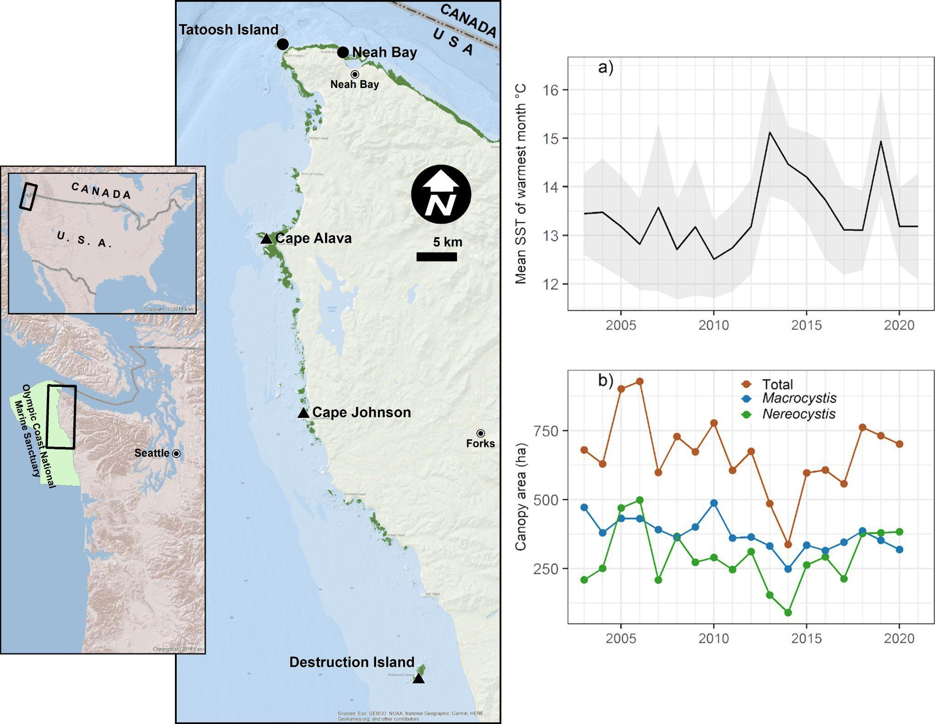

##### Figure 1. Location of the five study sites with distribution of floating kelp shown in green. Sites with round dots have wave/wind exposure scores of ~13k, whereas sites with triangles have scores of ~100-150k. Plots on right (2003-2021) are: a) Mean SST of the warmest month averaged across the five sites, and b) mean cover of canopy kelps summed across the five study sites. Gray envelope in (a) is +/- 1.0 s.d.

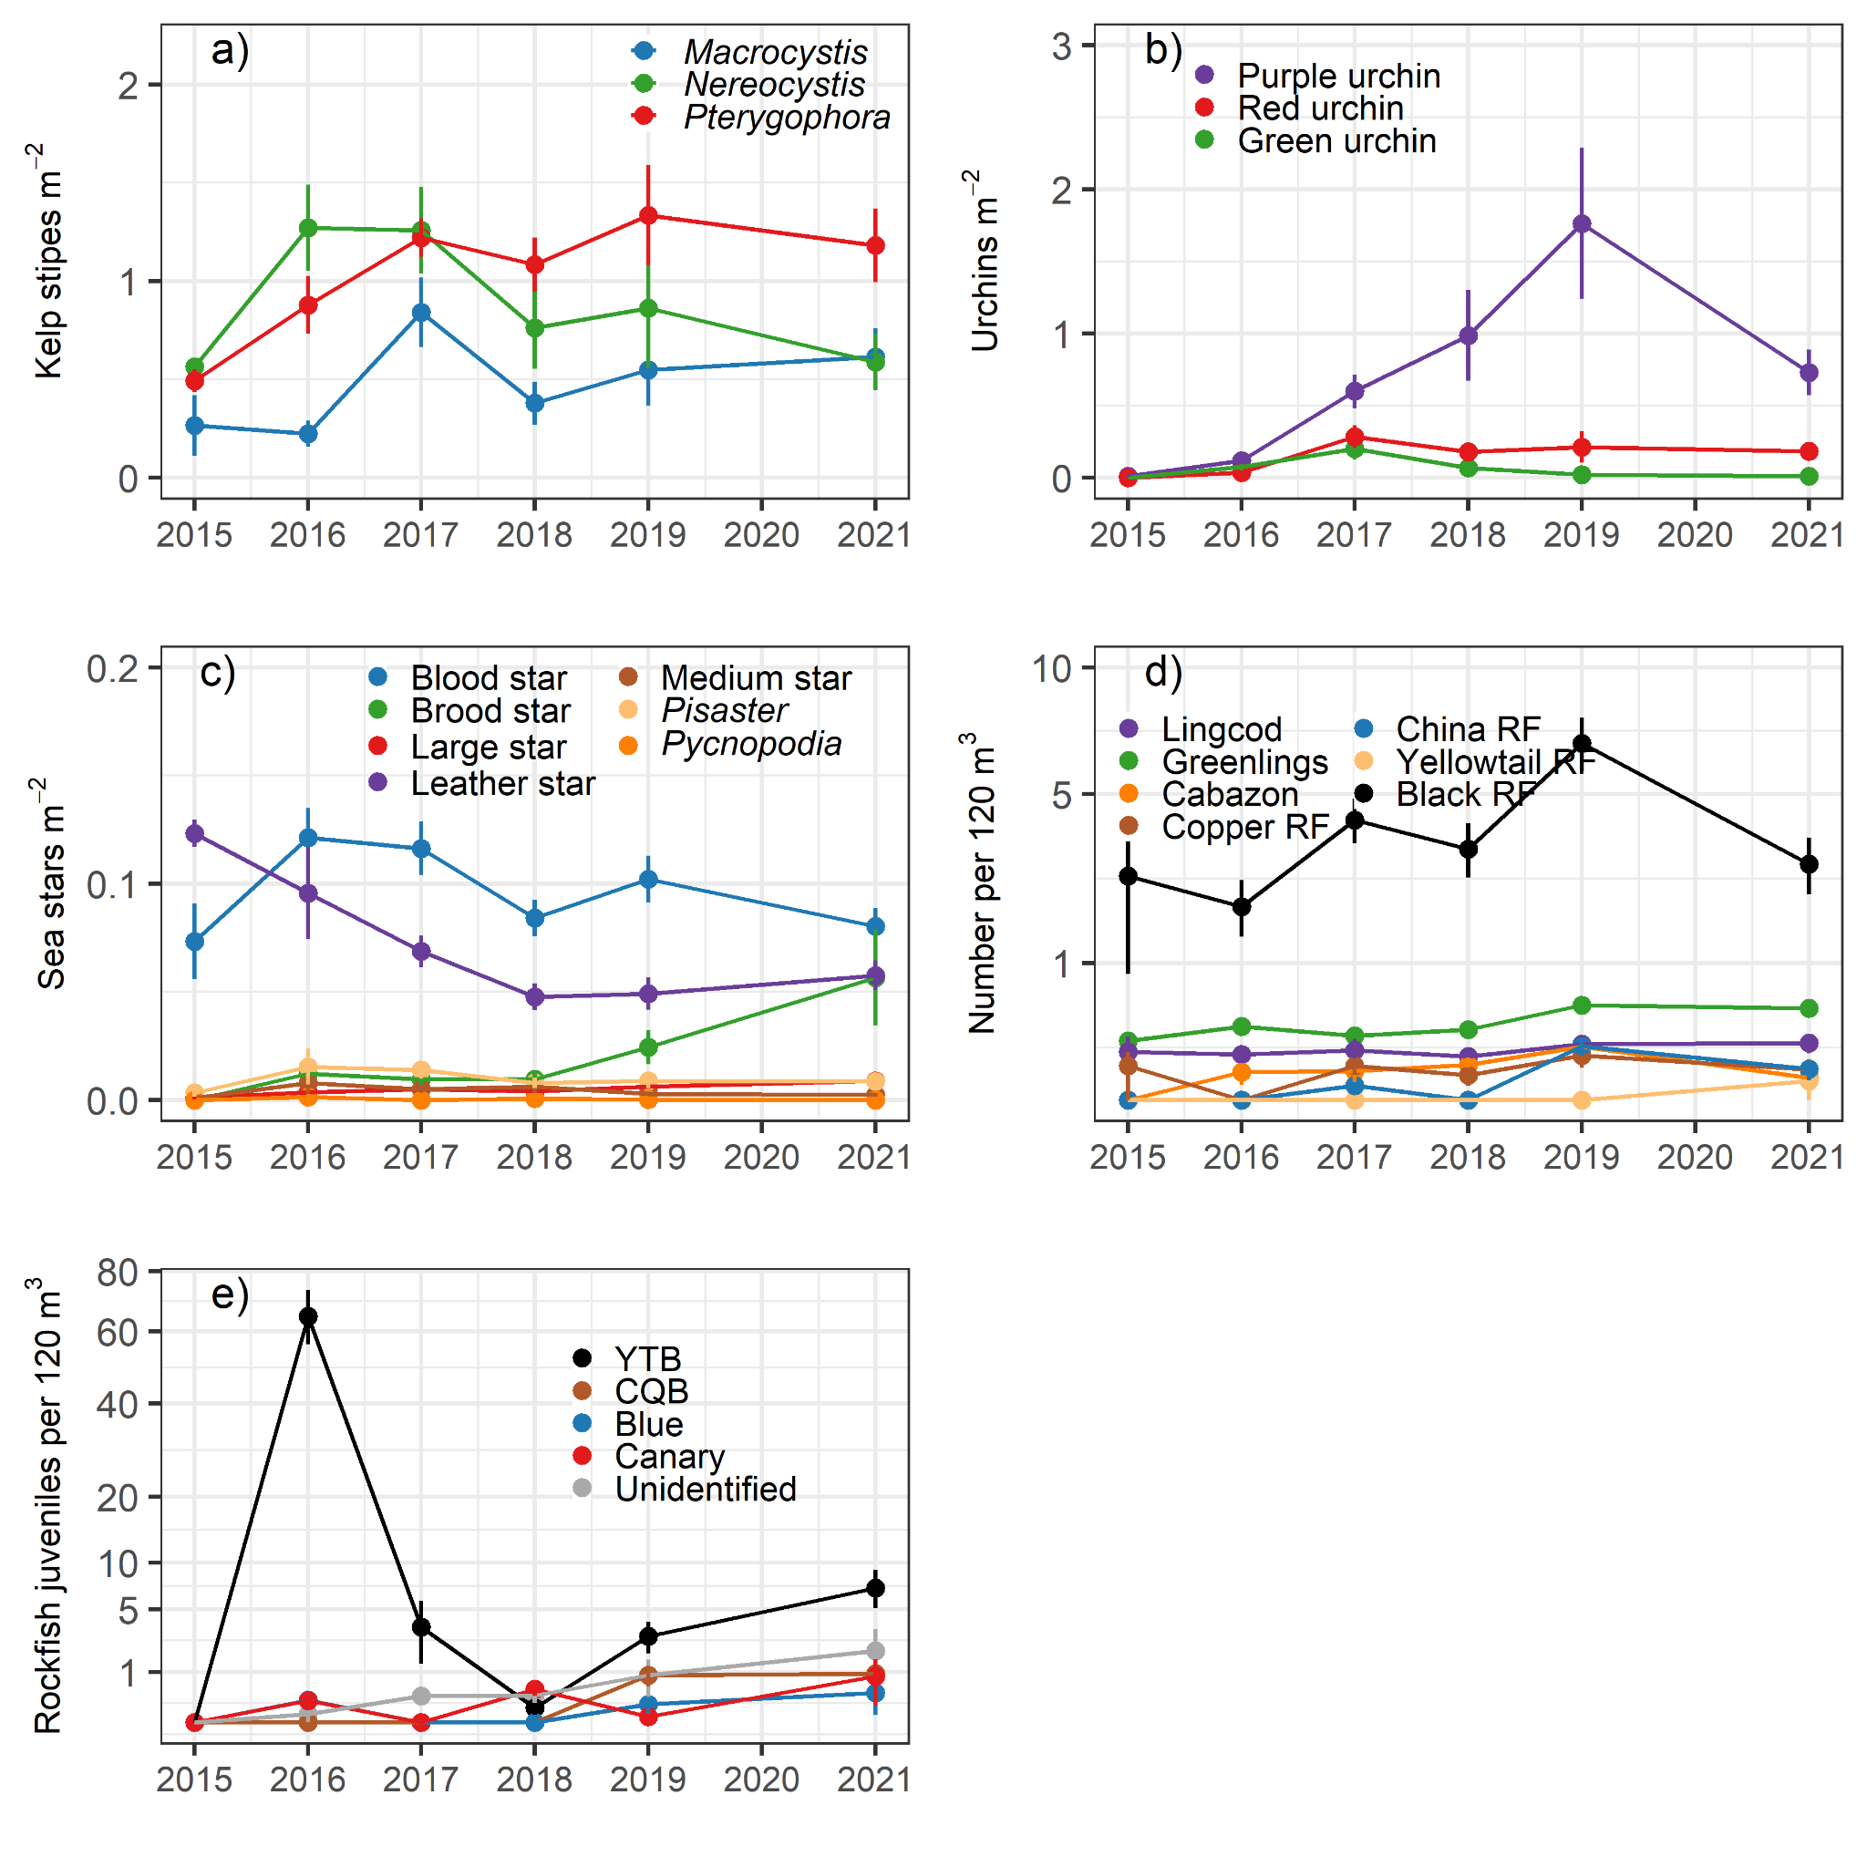

##### Figure 2. Time series of the focal groups coastwide from dive surveys from 2015-2021. a) density of kelp stipes, b) urchin density, c) sea star density, d) fish abundance, and e) abundance of juvenile rockfishes.

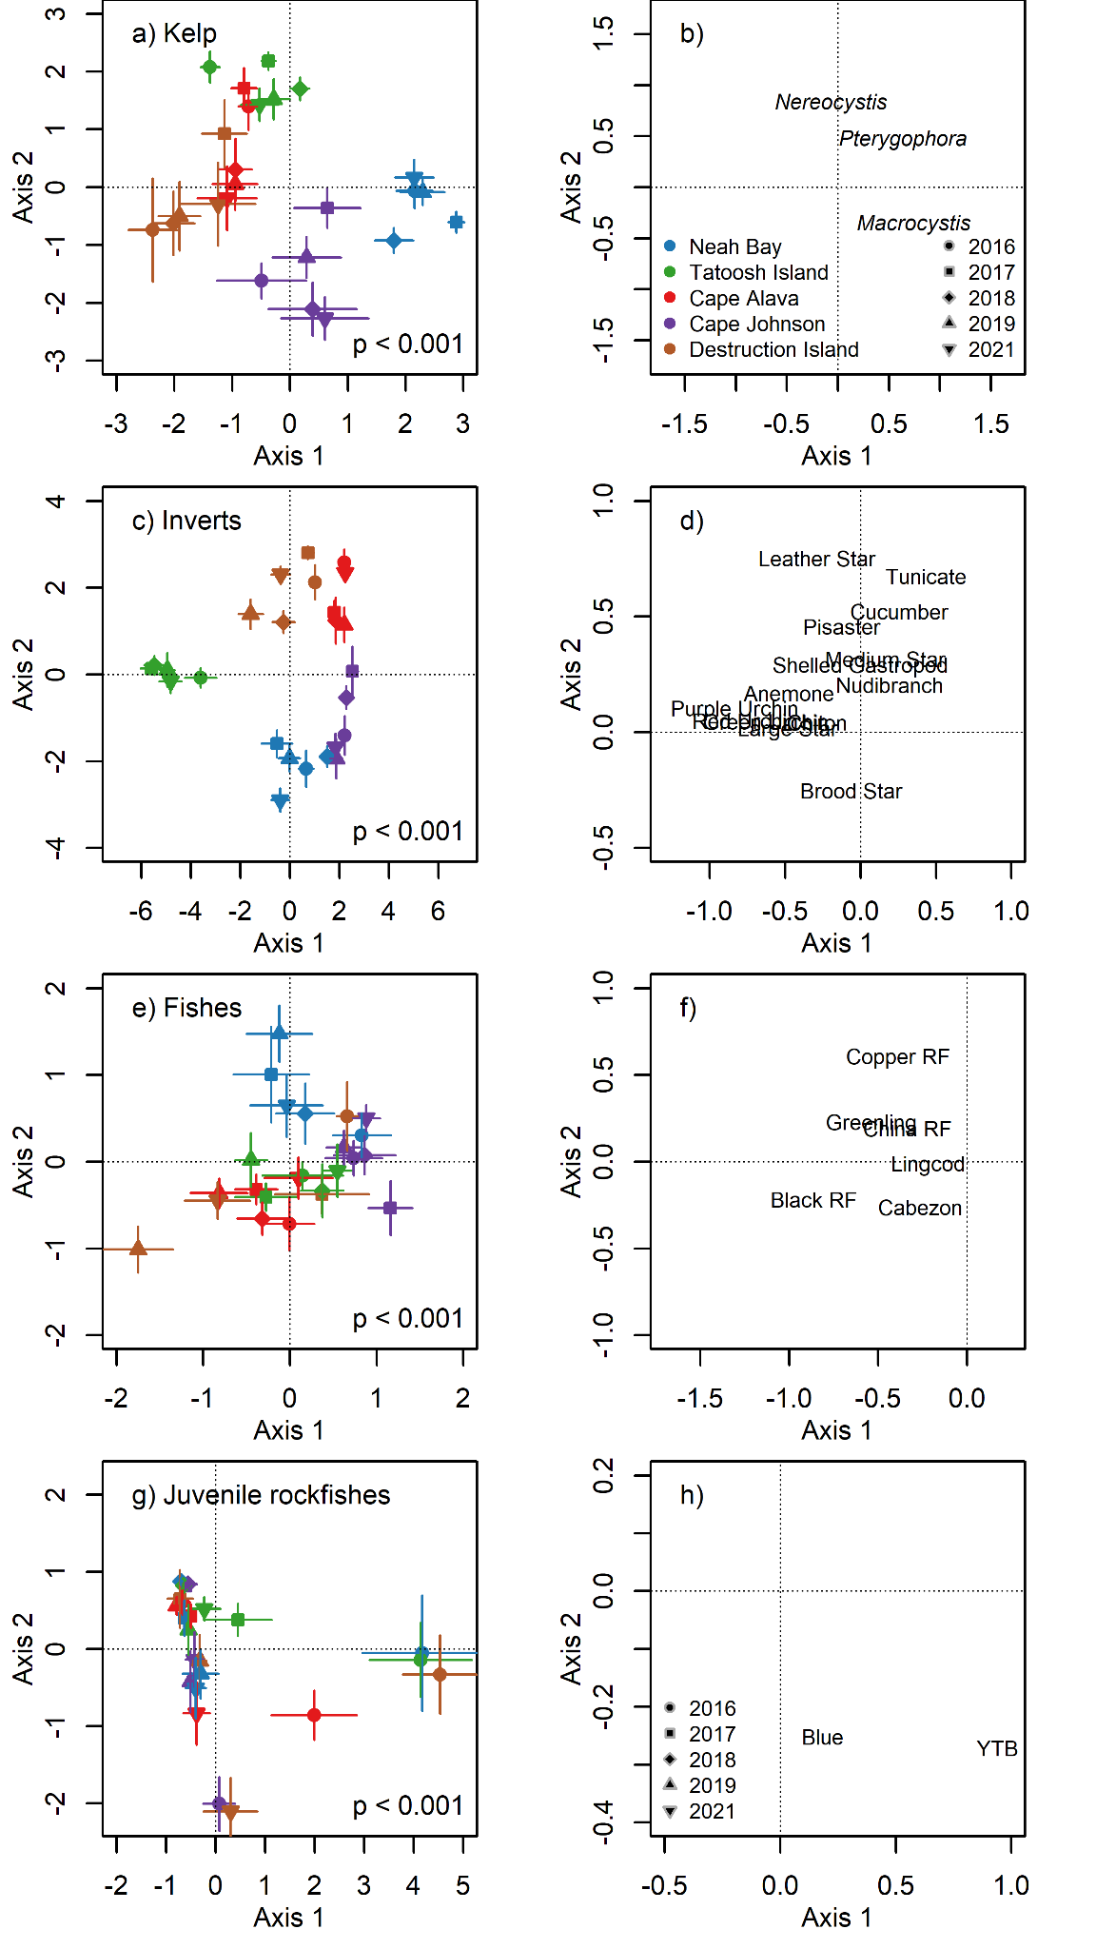

##### Figure 3. Results of canonical analysis of principal coordinates (CAP) of the assemblage structure of four guilds: kelps, invertebrates, fishes, and juvenile rockfishes. Left panes (a,c,e,g) show the ordination of Site x Year averages and p-values for the CAP analysis. Right panes (b,d,f,h) show the loadings for each taxon. RF = rockfish, YTB = yellow tail and black rockfish.

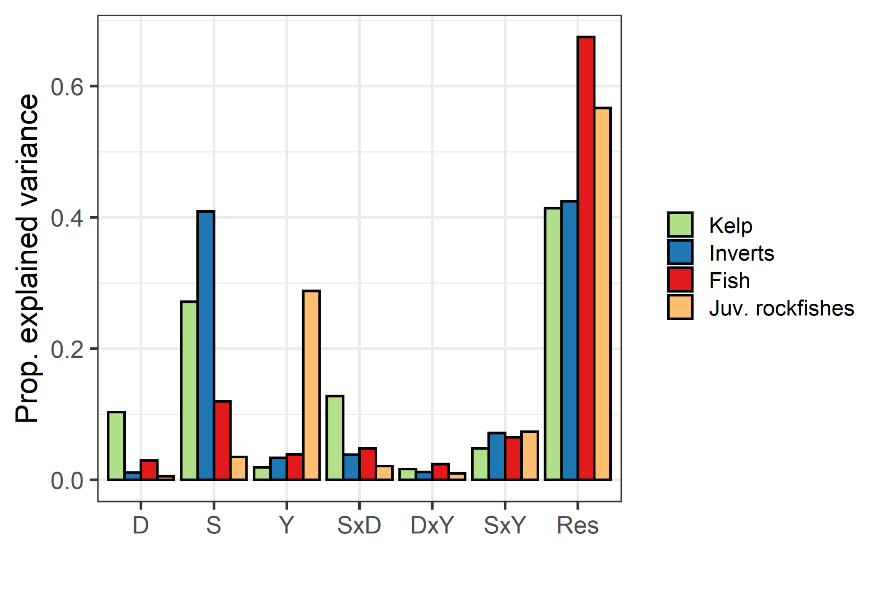

##### Figure 4. Explained variation from permutation-based multivariate analysis of variance (PerMANOVA) for four guilds: kelp, invertebrates, fish, and rockfish juveniles. All terms are fixed effects and results are the r2 values. D = depth, S = site, Y = year, Res = Residual.

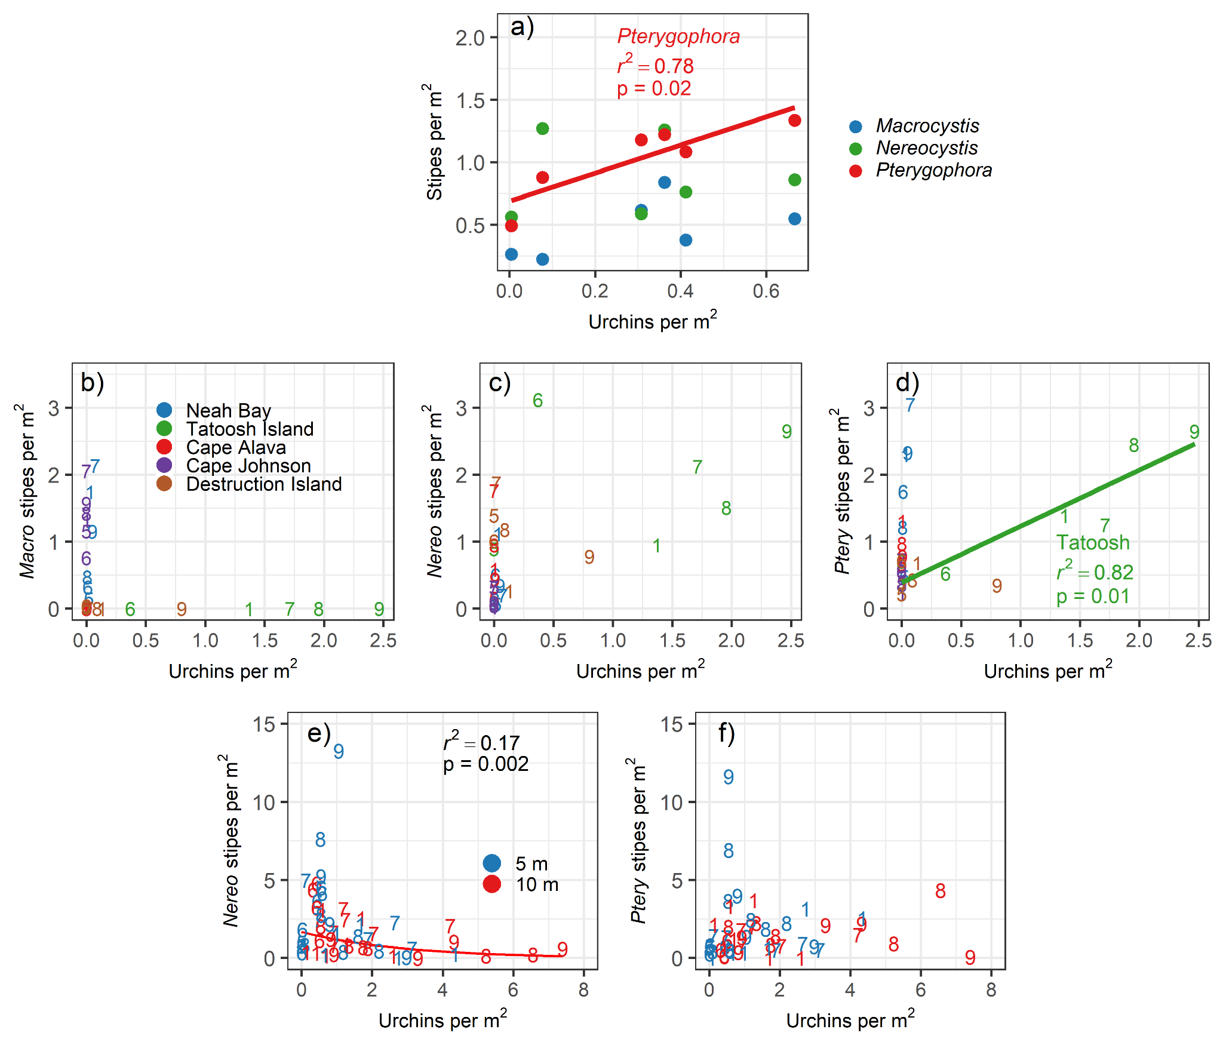

##### Figure 5. Relationship between the density of kelp stipe and total urchin density at different spatial scales: a) coastwide across years, site by year means for b) *Macrocystis*, c) *Nereocystis,* d) *Pterygophora,* and at the transect level at Tatoosh Island for e) *Nereocystis,* and f) *Pterygophora.* For panels e the regression is log(Y) = Urchin density. Other statistics are not logged. In panels b-f, numbered points refer to the year of data collection: 5 = 2015; 6 = 2016; 7 =2017; 8 = 2018; 9 =2019; 1=2021.

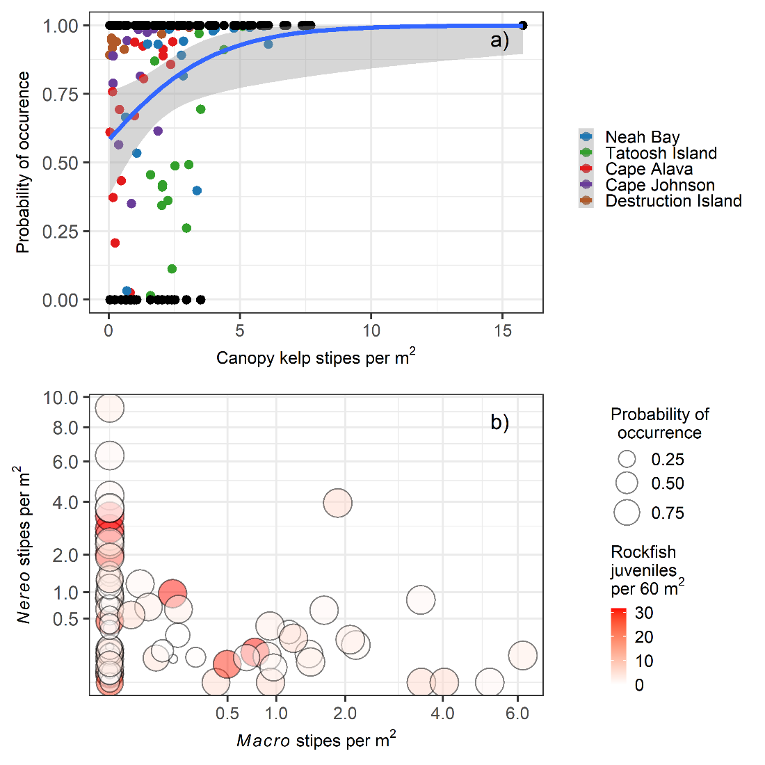

##### Figure 6. Relationship between kelp density and the abundance of rockfish juveniles from the hurdle model. (a) Probability of occurrence of juvenile rockfishes in relation to the total stipe density of the canopy kelps *Macrocystis and Nereocystis*. Blue line shows the result of the binomial presence/absence model. Black points are the actual observations (present =1, absent = 0). Colored points are predicted probability of occurrence. (b) Results of the combined presence/absence model and abundance model. Larger circles have a higher probability of occurrence. Data were summarized by Site x Depth x Location x Year strata prior to analysis.

# Supplementary Material

## Additional methods description

At each site, we conducted visual surveys on scuba on 30 x 2 m transects to quantify: 1) fish abundance, 2) macroinvertebrate abundance, 3) kelp abundance, 4) other biotic habitat, and 5) substratum type (abiotic habitat, e.g., cobble, pavement, etc) (modified from Pondella et al. (2019)). Kelp and invertebrates were surveyed along a 2-m wide swatch (60 m2), while fishes were counted within a 2-m x 2-m box along the transect (120 m3). At each site, we sample two locations, separated by 100+ m and marked by separate down lines, and at two depths at each location (5 m and 10 m). One pair of divers sampled fish and quantified biotic habitat. The second pair of divers sampled macroinvertebrates and kelp and quantified substratum type. The lead diver laid down the transect tape and counted fish or macroinvertebrates and kelp. The second diver followed recording biotic habitat or substratum characteristics respectively. Both biotic habitat and substratum type were quantified using uniform point contact (UPC) methods by recording the organism or substratum directly under every meter mark along the transect for 30 data points per transect. Each pair of divers began transects from the same drop point marked by the down-line and followed the same overall heading. However, pairs did not necessarily cover the exact same ground, so one cannot directly match fish counts to substratum characteristics at the transect level, for example. Therefore, we summarize data by year x site x location x depth for some analyses.

We counted canopy-forming kelp species within a 2-m swath along the 30-m transect (Table S2). For *Macrocystis pyrifera,* we counted stipes greater than 1.0 m in height. For *Nereocystis luetkeana* and *Pterygophora californica,* plants with stipes greater than 30 cm in height were included, along with other brown algae species greater than 30 cm in overall length. We used the segment subsampling for abundant species described for invertebrate species (see below Urchin and Kelp Segment Expansion).

Large mobile invertebrates were enumerated on the same transects as kelp (Table S3). We counted individuals greater than 2.5 cm in diameter or width, with the exception of sea stars where we measured radius. We counted individuals under prostrate algae and within bottom topography and on algae up to a height of 1.0 m above the substrate. This category included species of sea urchins, sea star, sea cucumbers, crabs, bivalves, nudibranchs, etc. We included only species that were easily identifiable to avoid concerns about the detection of cryptic species. For abundant species the transect was broken into 10-m segments, and the distance at which 30 individuals were counted per segment was noted, to be used in expansion calculations (see below Urchin and Kelp Segment Expansion). We also recorded sea urchin test diameter, sea star radius, and crab carapace width.

We counted and estimated the size (total length) of all fishes we observed within a 2-m wide swatch along the transect and within 2 m of the bottom (Table S4). We counted fishes greater than 5 cm total length; the exception was rockfishes *Sebastes* spp. for which we estimated sizes for all individuals, since we were interested in monitoring rockfish recruitment. Individuals ≤ 10 cm were considered juveniles (Table S5). Divers estimated visibility on each transect by determining the distance at which the lead diver could see the fingers of their buddy. Transects with visibility less than 2.0 m were excluded from analyses including fishes.

For biotic habitat, the diver recorded the organism directly under the transect every meter mark (universal point contact, UPC). Biotic habitat included the following functional groups: brown algae, red algae, green algae, encrusting species, diatom layer, eelgrass/surfgrass, non-mobile invertebrates, or non-living substratum (rock/sand). However, these data are not used in the present study.

We classified abiotic habitat (substratum) based on a simplified version of a system used extensively on the U.S. West Coast (Pearcy et al. 1989, Hixon et al. 1991, Stein et al. 1992, Greene et al. 1999, Tolimieri et al. 2008): sand, cobble, boulder, or bedrock; these features were recorded every meter (UPC). Additionally, we included an estimate of the slope every 10 m by estimating the drop in elevation across the 2-m width of the transect as: 0-10 cm, 10-100 cm, 1-2 m, or >2 m.

## 

## Supplement Tables

##### Table S1. Sampling effort. Number of transects completed by year and site. Kelp and invertebrates were counted on the same transects, while fish were counted on separate transects. For fish, transects with visibility lower than 2.0 m were removed resulting in no (NA) transects at some sites and years.

| Year | Site | Fish | Kelp/Invertebrates |
| --- | --- | --- | --- |
| 2015 | Cape Johnson | 2 | 2 |
| 2015 | Cape Alava | 2 | 2 |
| 2015 | Tatoosh Island | 2 | 2 |
| 2015 | Neah Bay | 2 | 2 |
| 2015 | Destruction Island | NA | 2 |
| 2016 | Destruction Island | 3 | 7 |
| 2016 | Cape Johnson | 10 | 13 |
| 2016 | Cape Alava | 12 | 10 |
| 2016 | Tatoosh Island | 8 | 9 |
| 2016 | Neah Bay | 10 | 10 |
| 2017 | Destruction Island | 4 | 12 |
| 2017 | Cape Johnson | 9 | 13 |
| 2017 | Cape Alava | 18 | 14 |
| 2017 | Tatoosh Island | 13 | 11 |
| 2017 | Neah Bay | 16 | 12 |
| 2018 | Cape Johnson | 7 | 12 |
| 2018 | Cape Alava | 16 | 12 |
| 2018 | Tatoosh Island | 15 | 12 |
| 2018 | Neah Bay | 15 | 14 |
| 2018 | Destruction Island | NA | 14 |
| 2019 | Destruction Island | 16 | 11 |
| 2019 | Cape Johnson | 15 | 14 |
| 2019 | Cape Alava | 16 | 14 |
| 2019 | Tatoosh Island | 14 | 9 |
| 2019 | Neah Bay | 15 | 14 |
| 2021 | Destruction Island | 10 | 11 |
| 2021 | Cape Johnson | 16 | 14 |
| 2021 | Cape Alava | 14 | 12 |
| 2021 | Tatoosh Island | 14 | 13 |
| 2021 | Neah Bay | 16 | 13 |

##### 

##### Table S2. Macroalgae species observed on transects from 2015-2021 across all sites. Mean density is stipes per m2 averaged across all sites and years.

| Species | Density | SD |
| --- | --- | --- |
| *Pterygophora californica* | 1.11 | 1.38 |
| *Nereocystis luetkeana* | 0.87 | 1.70 |
| *Macrocystis pyrifera* | 0.55 | 1.37 |
| *Laminaria setchellii* | 0.13 | 0.40 |
| *Saccharina dentigera* | 0.09 | 0.29 |
| *Pleurophycus gardneri* | 0.09 | 0.31 |
| *Desmarestia spp* | 0.07 | 0.21 |
| *Costaria costata* | 0.06 | 0.17 |
| *Saccharina latissima* | 0.04 | 0.22 |
| *Alaria marginata* | 0.01 | 0.06 |
| *Cymathere triplicata* | 0.00 | 0.02 |
| *Agarum fimbriatum* | 0.00 | 0.04 |

##### 

##### Table S3. Invertebrate species showing group designation in the multivariate analyses. Density is the number per m2 across all sites and years. SD = 1.0 standard deviation. Values of 0.0 indicate density less than 0.01 per m2. The following groups were used in the multivariate analyses: anemone, blood star, brood star, chiton, crabs, cucumber, green urchin, hermit crabs, kelp crab, large star, leather star, medium star, nudibranch, *Pisaster*, purple urchin, *Pycnopodia*, red urchin, shelled gastropod, sponge, and tunicate.

| Species | Multivariate Group | Density | SD |
| --- | --- | --- | --- |
| *Balanus nubilus* | barnacle | 0.83 | *3.67* |
| *Strongylocentrotus purpuratus* | purple urchin | 0.71 | 2.40 |
| *Nucella lamellosa* | shelled gastropod | 0.29 | 1.36 |
| *Mesocentrotus franciscanus* | red urchin | 0.16 | 0.60 |
| *Cucumaria miniata* | cucumber | 0.11 | 0.16 |
| *Henricia leviuscula* | blood star | 0.10 | 0.09 |
| *Styela montereyensis* | tunicate | 0.09 | 0.14 |
| *Strongylocentrotus droebachiensis* | green urchin | 0.06 | 0.31 |
| *Dermasterias imbricata* | leather star | 0.06 | 0.10 |
| *Ceratostoma foliatum* | shelled gastropod | 0.05 | 0.09 |
| *Crassadoma gigantea* | bivalve | 0.03 | 0.08 |
| *Diodora aspera* | shelled gastropod | 0.02 | 0.05 |
| *Leptasterias* spp. | brood star | 0.02 | 0.09 |
| *Urticina* spp. | anemone | 0.02 | 0.04 |
| *Pisaster ochraceus* | *Pisaster* | 0.02 | 0.06 |
| *Eupentacta quinquesemita* | cucumber | 0.01 | 0.03 |
| *Anthopleura xanthogrammica* | anemone | 0.01 | 0.03 |
| *Peltodoris nobilis* | nudibranch | 0.01 | 0.02 |
| small chitons | chiton | 0.01 | 0.02 |
| *Patiria miniata* | medium star | 0.01 | 0.04 |
| *Evasterias troschelii* | large star | 0.01 | 0.02 |
| *Doris odhneri* | nudibranch | 0.01 | 0.02 |
| *Scyra* spp*.* | crabs | 0.01 | 0.02 |
| *Orthasterias koehleri* | large star | 0.01 | 0.02 |
| *Cryptochiton stelleri* | chiton | 0.01 | 0.01 |
| *Dirona albolineata* | nudibranch | 0.01 | 0.02 |
| *Acmaea mitra* | shelled gastropod | 0.00 | 0.01 |
| *Lirabuccinum dirum* | shelled gastropod | 0.00 | 0.02 |
| sea star recruits | sea_star_YOY | 0.00 | 0.03 |
| *Epiactis prolifera* | anemone | 0.00 | 0.03 |
| *Pagurus* spp. | hermit_crabs | 0.00 | 0.02 |
| *Triopha catalinae* | nudibranch | 0.00 | 0.01 |
| *Cancer* spp*.* | crabs | 0.00 | 0.01 |
| *Craniella arb* | sponge | 0.00 | 0.01 |
| *Janolus fuscus* | nudibranch | 0.00 | 0.01 |
| *Acanthodoris hudsoni* | nudibranch | 0.00 | 0.01 |
| *Cancer oregonensis* | crabs | 0.00 | 0.01 |
| *Parastichopus californicus* | cucumber | 0.00 | 0.01 |
| *Pugettia producta* | kelp crab | 0.00 | 0.01 |
| *Mytilus californianus* | shelled mussel | 0.00 | 0.01 |
| *Pugettia gracilis* | kelp crab | 0.00 | 0.01 |
| *Urticina crassicornis* | anemone | 0.00 | 0.01 |
| *Pododesmus* spp. | bivalve | 0.00 | 0.01 |
| *Solaster stimpsoni* | large star | 0.00 | 0.01 |
| *Cryptolithodes sitchensis* | crabs | 0.00 | 0.00 |
| *Urticina lofotensis* | anemone | 0.00 | 0.01 |
| *Mediaster aequalis* | medium star | 0.00 | 0.00 |
| *Urticina piscivora* | anemone | 0.00 | 0.00 |
| *Pycnopodia helianthoides* | Pycnopodia | 0.00 | 0.00 |
| *Fusitriton oregonensis* | shelled gastropod | 0.00 | 0.00 |
| *Pisaster brevispinus* | Pisaster | 0.00 | 0.00 |
| *Mimulus foliatus* | crabs | 0.00 | 0.00 |
| misc clams | bivalve | 0.00 | 0.00 |
| *Metridium giganteum* | anemone | 0.00 | 0.00 |
| *Lopholithodes mandtii* | crabs | 0.00 | 0.00 |
| *Anthopleura elegantissima* | anemone | 0.00 | 0.00 |

##### 

##### Table S4. Fish species observed during SCUBA surveys from 2015-2021. Observations with visibility below 2.0 m have been excluded. Greenlings were combined into one group for the multivariate analyses. Species in bold were used in the multivariate analyses.

| **Species** | **Common name** | **Total** |
| --- | --- | --- |
| ***Sebastes melanops*** | **black rockfish** | **1387** |
| ***Hexagrammos decagrammus*** | **kelp greenling** | **522** |
| *Embiotoca lateralis* | striped surfperch | 470 |
| *Aulorhynchus flavidus* | tubesnout | 240 |
| bait | bait-sardines-anchovy | 200 |
| Clupeidae | herring | 148 |
| ***Ophiodon elongatus*** | **lingcod** | **45** |
| *Rhinogobiops nicholsii* | blackeye goby | 28 |
| ***Scorpaenichthys marmoratus*** | **cabezon** | **23** |
| ***Sebastes caurinus*** | **copper rockfish** | **20** |
| ***Sebastes maliger*** | **quillback rockfish** | **19** |
| ***Sebastes nebulosus*** | **china rockfish** | **17** |
| *Artedius harringtoni* | scalyhead sculpin | 15 |
| *Rhacochilus vacca* | pile perch | 11 |
| *Cottidae* | sculpins | 7 |
| *Hemilepidotus hemilepidotus* | red Irish lord | 7 |
| ***Oxylebius pictus*** | **painted greenling** | **7** |
| *Embiotocidae* | surfperches | 5 |
| ***Hexagrammos lagocephalus*** | **rock greenling** | **5** |
| *Synchirus gilli* | manacled sculpin | 5 |
| ***Hexagrammos stelleri*** | **whitespotted greenling** | **4** |
| *Jordania zonope* | longfin sculpin | 4 |
| *Chirolophis nugator* | mosshead warbonnet | 3 |
| *Rimicola muscarum* | kelp clingfish | 3 |
| Pholidae | gunnels | 1 |
| *Sebastes flavidus* | yellowtail rockfish | 1 |
| fish | unidentified fish | 1 |

##### Table S5. Rockfish juveniles observed during SCUBA surveys from 2015-2021. Observations with visibility below 2.0 m were excluded.

| **Species** | **Common name** | **Total** |
| --- | --- | --- |
| *Sebastes melanops/flavidus* | Yellowtail and black rockfish juveniles (YTB) | 3544 |
| *Sebastes* spp. juveniles | rockfish juveniles | 199 |
| *Sebastes caurinus/maliger/auriculatus* | Copper, quillback, and brown rockfishes (CQB) | 141 |
| *Sebastes pinniger* | canary rockfish | 103 |
| *Sebastes mystinus* | blue rockfish | 36 |
|  |  |  |
|  |  |  |

## 

##### Table S6. Results of permutation-based multivariate analysis of variance PerMANOVA for kelp assemblage structure at five sites along the Washington coast at two depths (5-m, 10-m) from 2016-2021.

|  | DF | MS | R2 | F | p-value |
| --- | --- | --- | --- | --- | --- |
| Depth | 1 | 4.48 | 0.10 | 62.56 | 0.001 |
| Site | 4 | 11.80 | 0.27 | 41.19 | 0.001 |
| Year | 4 | 0.82 | 0.02 | 2.88 | 0.002 |
| Depth x Site | 4 | 5.55 | 0.13 | 19.38 | 0.001 |
| Depth X Year | 4 | 0.71 | 0.02 | 2.49 | 0.002 |
| Site X Year | 16 | 2.08 | 0.05 | 1.82 | 0.001 |
| Residual | 251 | 17.97 | 0.41 |  |  |

##### Table S7. Results of permutation-based multivariate analysis of variance PerMANOVA for invertebrate assemblage structure at five sites along the Washington coast at two depths (5-m, 10-m) from 2016-2021.

|  | DF | MS | R2 | F | p-value |
| --- | --- | --- | --- | --- | --- |
| Depth | 1 | 0.63 | 0.01 | 6.80 | 0.001 |
| Site | 4 | 23.26 | 0.41 | 62.64 | 0.001 |
| Year | 4 | 1.91 | 0.03 | 5.14 | 0.001 |
| Depth x Site | 4 | 2.18 | 0.04 | 5.87 | 0.001 |
| Depth X Year | 4 | 0.68 | 0.01 | 1.83 | 0.022 |
| Site X Year | 16 | 4.07 | 0.07 | 2.74 | 0.001 |
| Residual | 260 | 24.13 | 0.42 |  |  |

## 

##### Table S8. Results of permutation-based multivariate analysis of variance PerMANOVA for fish assemblage structure at five sites along the Washington coast at two depths (5-m, 10-m) from 2016-2021.

|  | DF | MS | R2 | F | p-value |
| --- | --- | --- | --- | --- | --- |
| Depth | 1 | 0.92 | 0.03 | 11.68 | 0.001 |
| Site | 4 | 3.74 | 0.12 | 11.94 | 0.001 |
| Year | 4 | 1.23 | 0.04 | 3.91 | 0.001 |
| Depth x Site | 4 | 1.49 | 0.05 | 4.76 | 0.001 |
| Depth X Year | 4 | 0.74 | 0.02 | 2.38 | 0.018 |
| Site X Year | 15 | 2.02 | 0.06 | 1.72 | 0.01 |
| Residual | 269 | 21.08 | 0.68 |  |  |

##### Table S9. Results of permutation-based multivariate analysis of variance PerMANOVA for rockfish *Sebastes* spp young of year assemblage structure at five sites along the Washington coast at two depths (5-m, 10-m) from 2016-2021.

|  | DF | MS | R2 | F | p-value |
| --- | --- | --- | --- | --- | --- |
| Depth | 1 | 0.22 | 0.01 | 2.62 | 0.064 |
| Site | 4 | 1.37 | 0.03 | 4.13 | 0.001 |
| Year | 4 | 11.33 | 0.29 | 34.18 | 0.001 |
| Depth x Site | 4 | 0.82 | 0.02 | 2.48 | 0.011 |
| Depth X Year | 4 | 0.40 | 0.01 | 1.21 | 0.254 |
| Site X Year | 15 | 2.89 | 0.07 | 2.33 | 0.001 |
| Residual | 269 | 22.30 | 0.57 |  |  |

##### Table S10 Results of model selection for binomial models predicting the probability of occurrence of juvenile rockfishes. Data were summarized by Site x Depth x Area x Year bins prior to analysis. *Macro = Macrocystis, Nereo = Nereocystis, Ptery = Pterygophora. Canopy kelps are Macrocystis and Nereocystis.* Kelps were included as continuous variables, Year and Site and random factors and included in all models.

| Model | AICc | | ΔAICc |
| --- | --- | --- | --- |
| Canopy kelps summed | 70.485 | 0.000 | |
| *Macro* + *Nereo* | 72.485 | 1.999 | |
| Three kelps summed | 73.686 | 3.200 | |
| *Macro* + *Nereo* + *Ptery* | 73.764 | 3.279 | |
| *Nereo* + *Ptery* | 75.231 | 4.746 | |
| *Nereo* | 76.421 | 5.935 | |
| *Macro* | 83.970 | 13.484 | |
| *Macro* + *Ptery* | 84.142 | 13.656 | |
| *Ptery* | 85.400 | 14.914 | |
| Year only | 86.929 | 16.444 | |
| Year + Site only | 87.704 | 17.218 | |

##### Table S11. Model coefficients for a) the best-fit binomial model: summed canopy kelp, b) the binomial model including *Macrocystis* and *Nereocystis* as predictors, and c) the best-fit positive abundance model.

1. Canopy kelp - occurrence

| Random effect | Variance | SD |  |  |
| --- | --- | --- | --- | --- |
| Year | 5.33 | 2.31 |  |  |
| Site | 3.25 | 1.80 |  |  |
|  |  |  |  |  |
| Fixed effect | Estimate | SE | z-value | P |
| Intercept | -0.274 | 1.447 | -0.189 | 0.850 |
| Canopy kelp summed | 2.553 | 1.009 | 2.531 | 0.011 |

1. *Macrocystis* and *Nereocystis* - occurrence

| Random effect | Variance | SD |  |  |
| --- | --- | --- | --- | --- |
| Year | 5.31 | 2.30 |  |  |
| Site | 3.28 | 1.81 |  |  |
|  |  |  |  |  |
| Fixed effect | Estimate | SE | z-value | P |
| Intercept | -0.272 | 1.449 | -0.188 | 0.851 |
| *Macrocystis* | 2.517 | 1.608 | 1.565 | 0.117 |
| *Nereocystis* | 2.570 | 1.174 | 2.189 | 0.027 |

1. *Macrocystis* and *Nereocystis* - occurrence

| Random effect | Variance | SD |  |  |
| --- | --- | --- | --- | --- |
| Year | 1.965 | 1.402 |  |  |
| Residual | 1.770 | 1.330 |  |  |
|  |  |  |  |  |

##### 

##### Table S12 Results of model selection for abundance only models estimating abundance of juvenile rockfishes. Data were summarized by Site x Depth x Area x Year bins prior to analysis. *Macro = Macrocystis, Nereo = Nereocystis, Ptery = Pterygophora. Canopy kelps are Macrocystis and Nereocystis.* Kelps were included as continuous variables, Year and Site and random factors and included in all models.

| Model | AICc | ΔAICc |
| --- | --- | --- |
| Year | 236.014 | 0.000 |
| Year + Site | 238.187 | 2.173 |
| *Macro* | *240.415* | *4.401* |
| *Nereo* | 242.732 | 6.718 |
| Canopy kelp summed | 243.299 | 7.285 |
| Three kelps summed | 243.967 | 7.953 |
| *Macro* + *Ptery* | 244.992 | 8.978 |
| *Macro* +*Nereo* | 245.356 | 9.342 |
| *Ptery* | 245.403 | 9.389 |
| *Macro* +*Nereo* + *Ptery* | 249.667 | 13.653 |

## 

## Supplement Figures

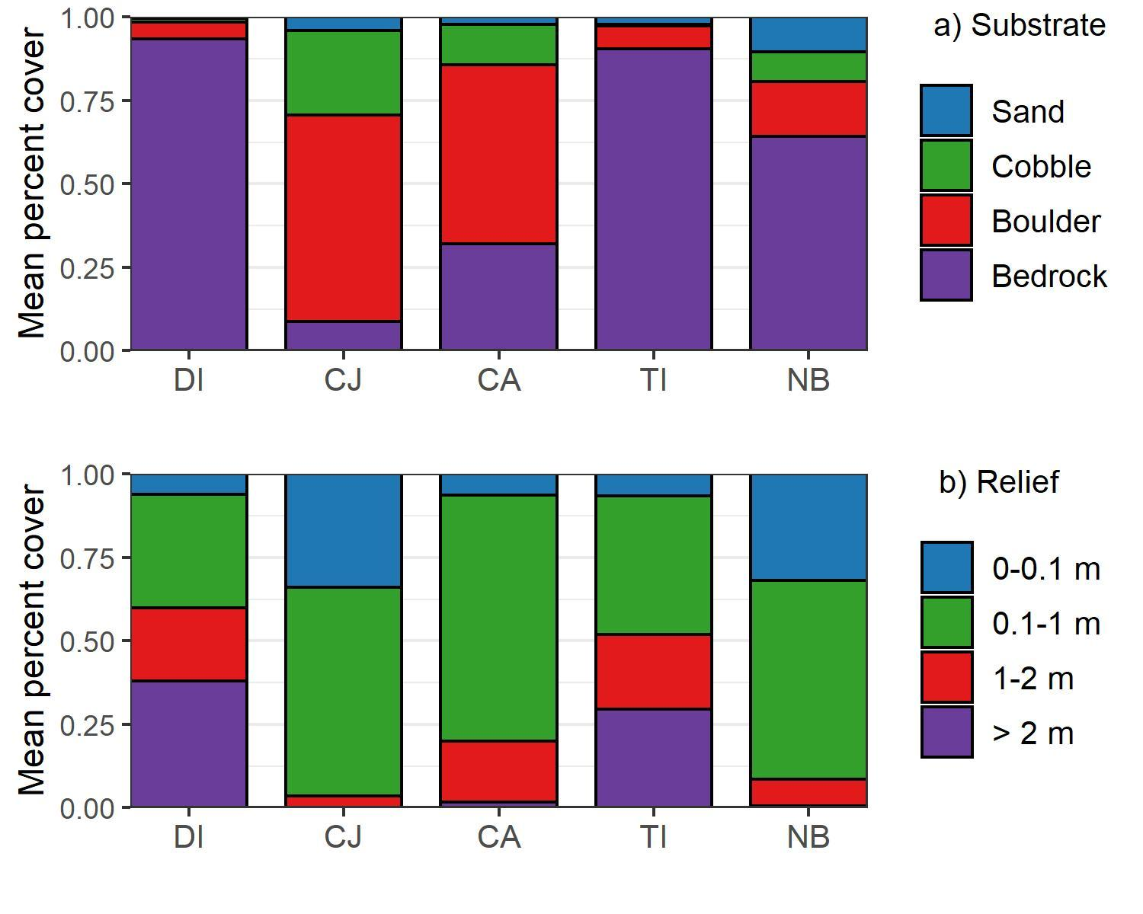

##### Figure S1. Substrate and relief at the five sites: DI = Destruction Island, CJ = Cape Johnson, CA = Cape Alava, TI = Tatoosh Island, NB = Neah Bay.

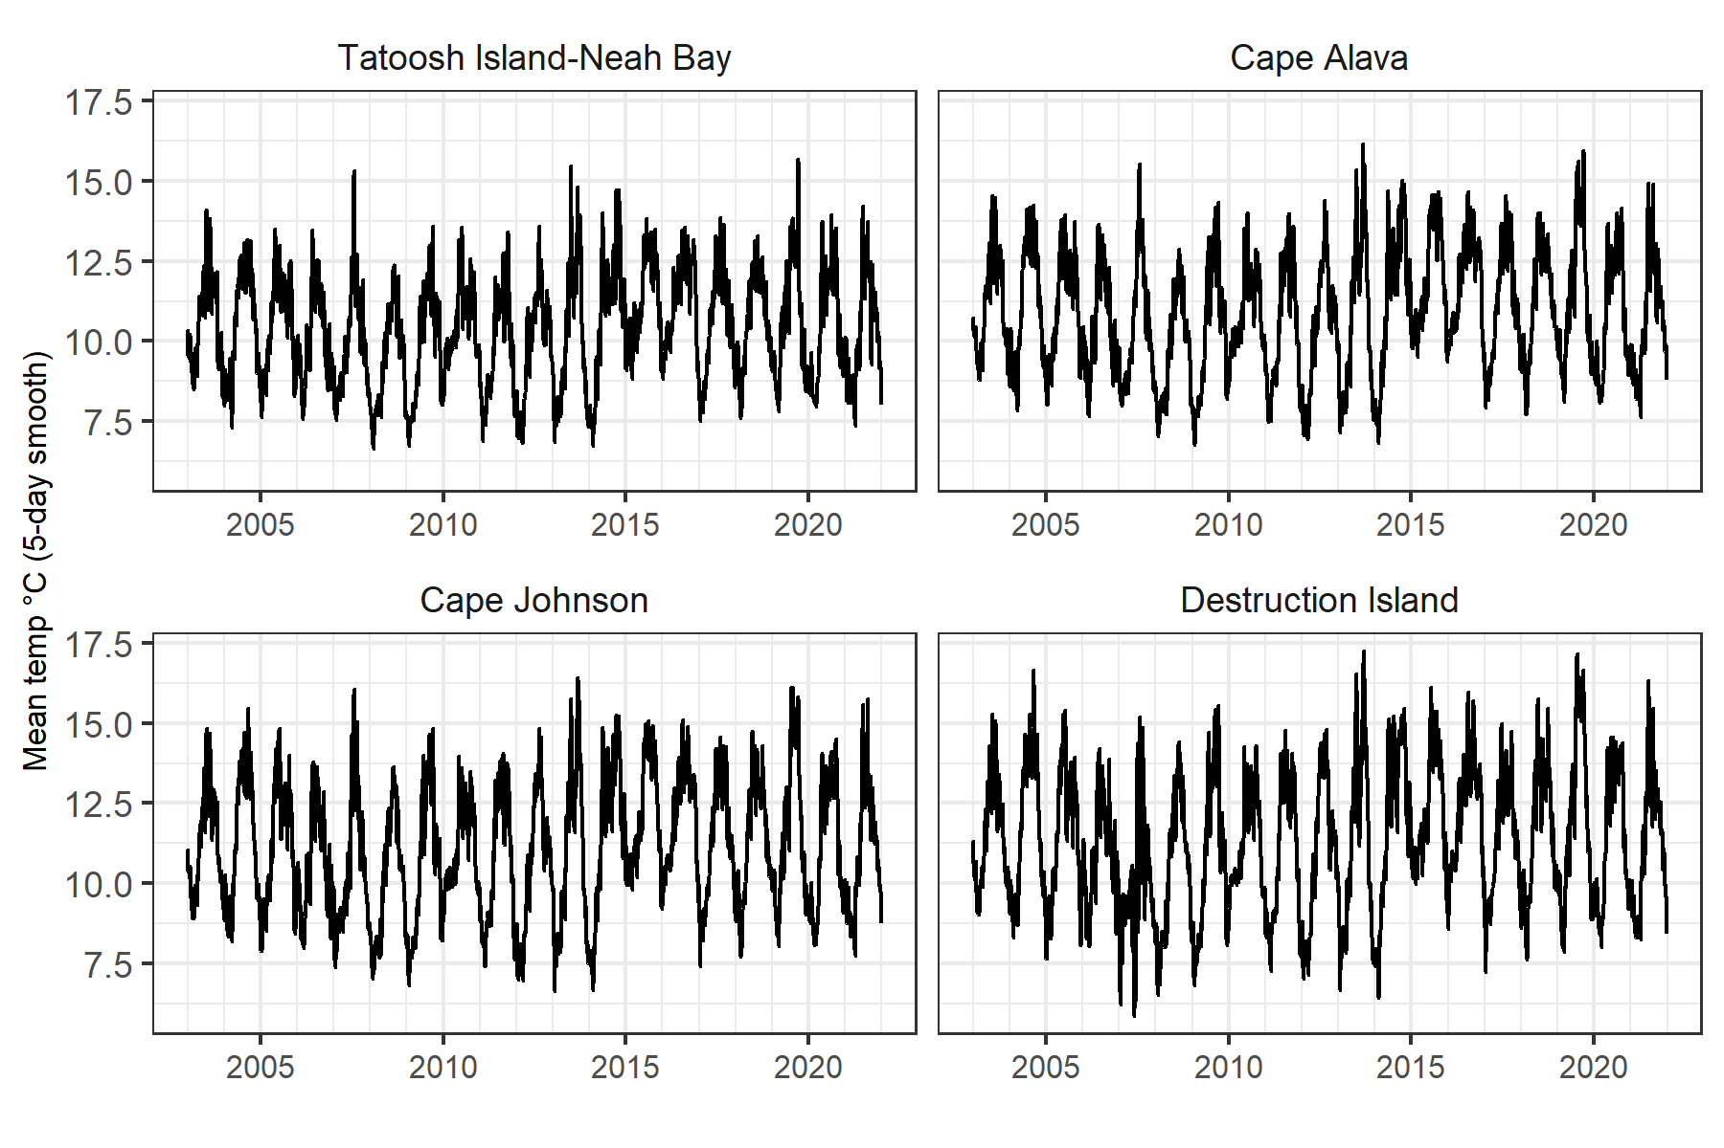

##### Figure S2. Mean SST at the five sites (5-day smooth) from 2003-2021. Note Tatoosh Island and Neah Bay are in the same interpolated grid cell and combined in pane 1.

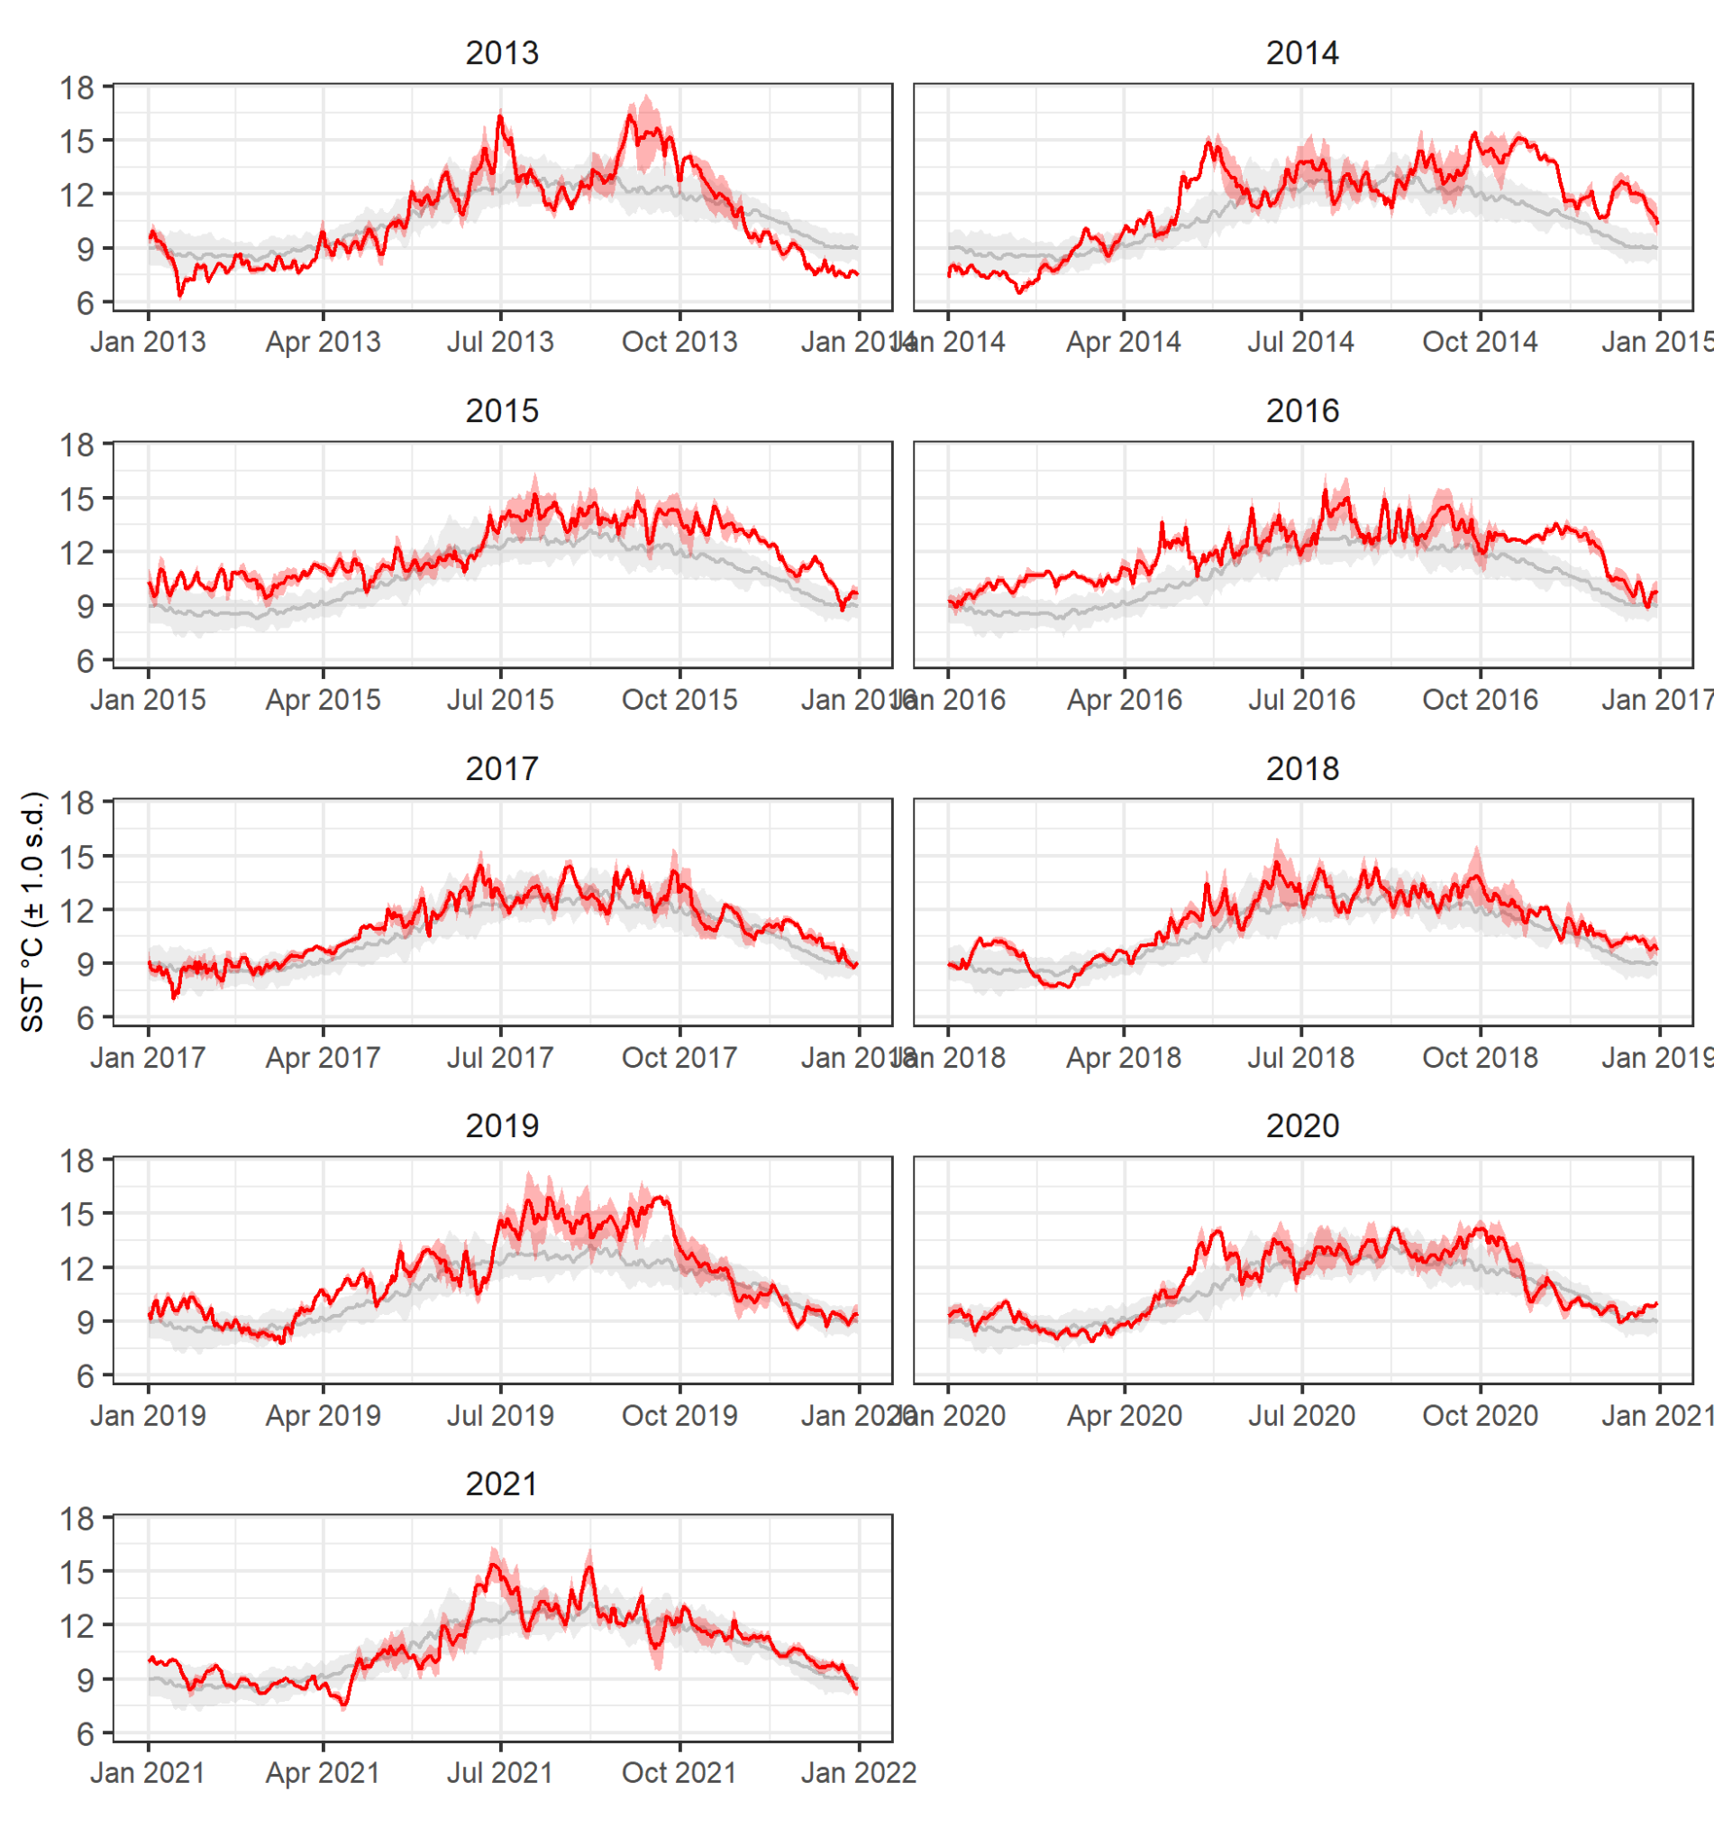

##### Figure S3. Yearly progression of SST for 2013-2021 compared to the average of 2003-2012

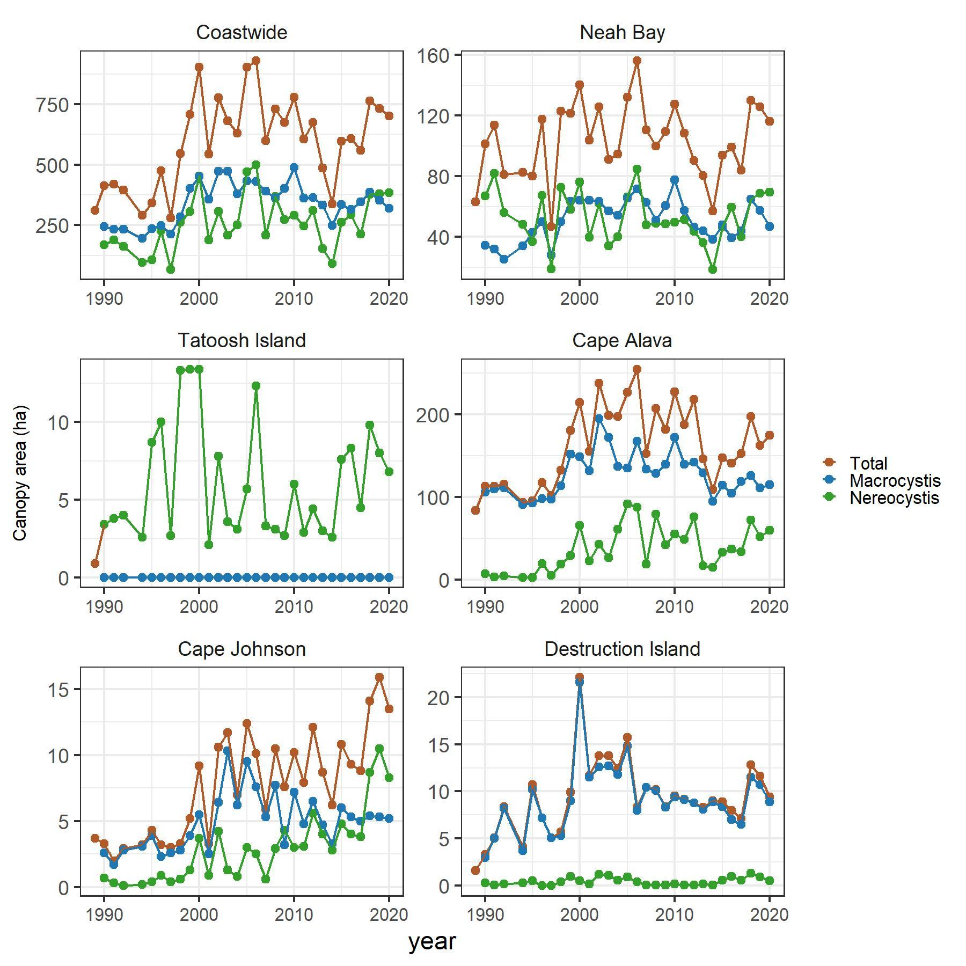

##### Figure S4. Canopy area of *Nereocystis* and *Macrocystis* from 1989 to 2020 coastwide and at five sites along the Washington coast. Canopy area is the spatial extent of individual surface kelp plants and canopies (Van Wagenen 2015). Note, there was no *Macrocystis* at Tatoosh Island, so the Total and *Nereocystis* values overlap.

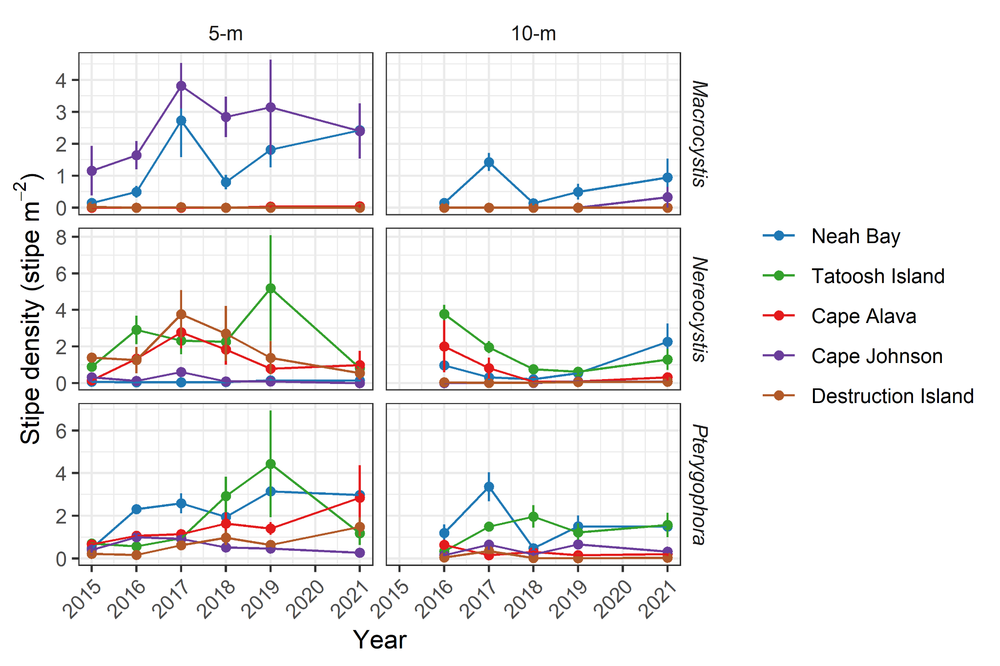

##### Figure S5. Stipe density for the three primary kelps at five sites and two depths from 2015-2021.

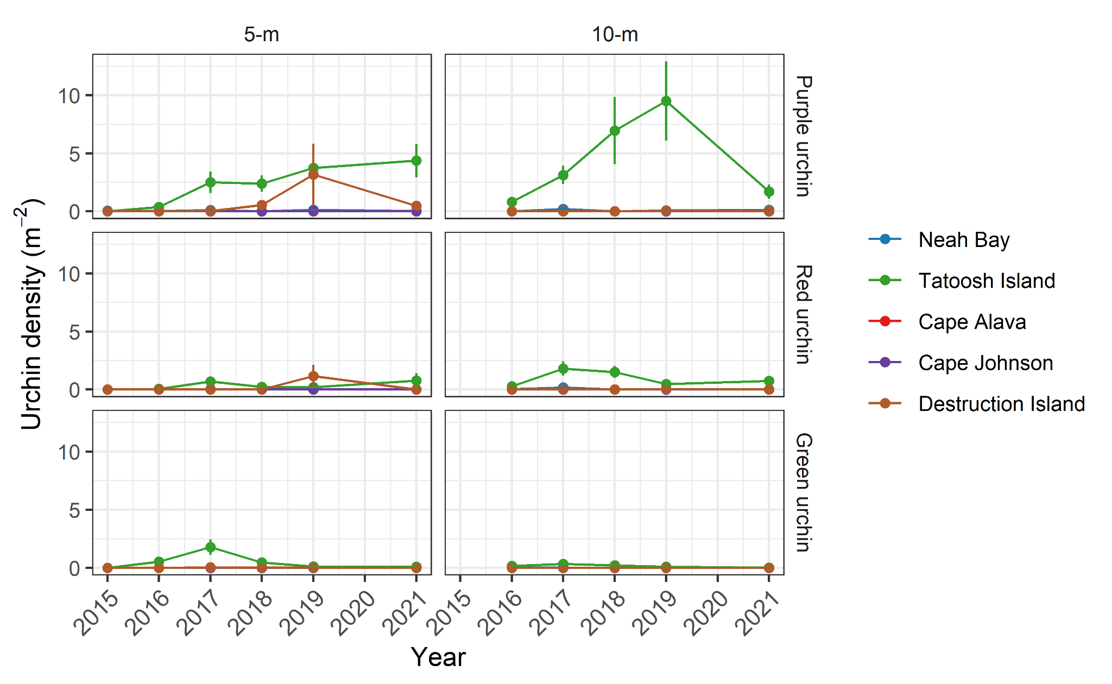

##### Figure S6. Abundance of urchins at five sites and two depths from 2015-2021.

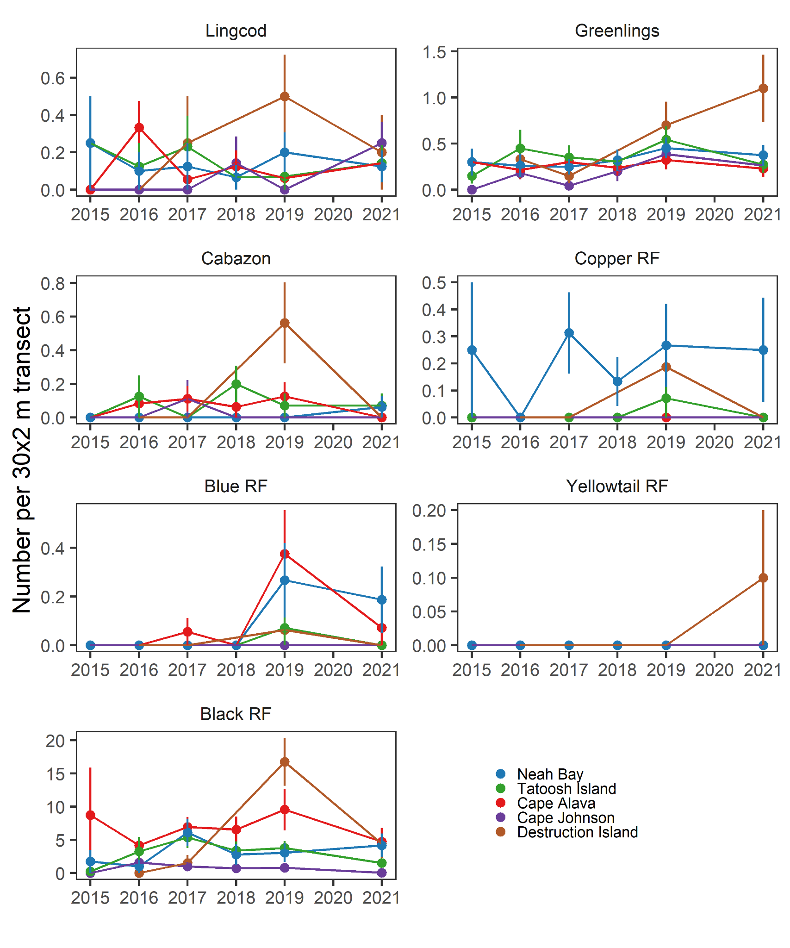

##### Figure S7. Abundance of seven fish species at five sites from 2015-2021.

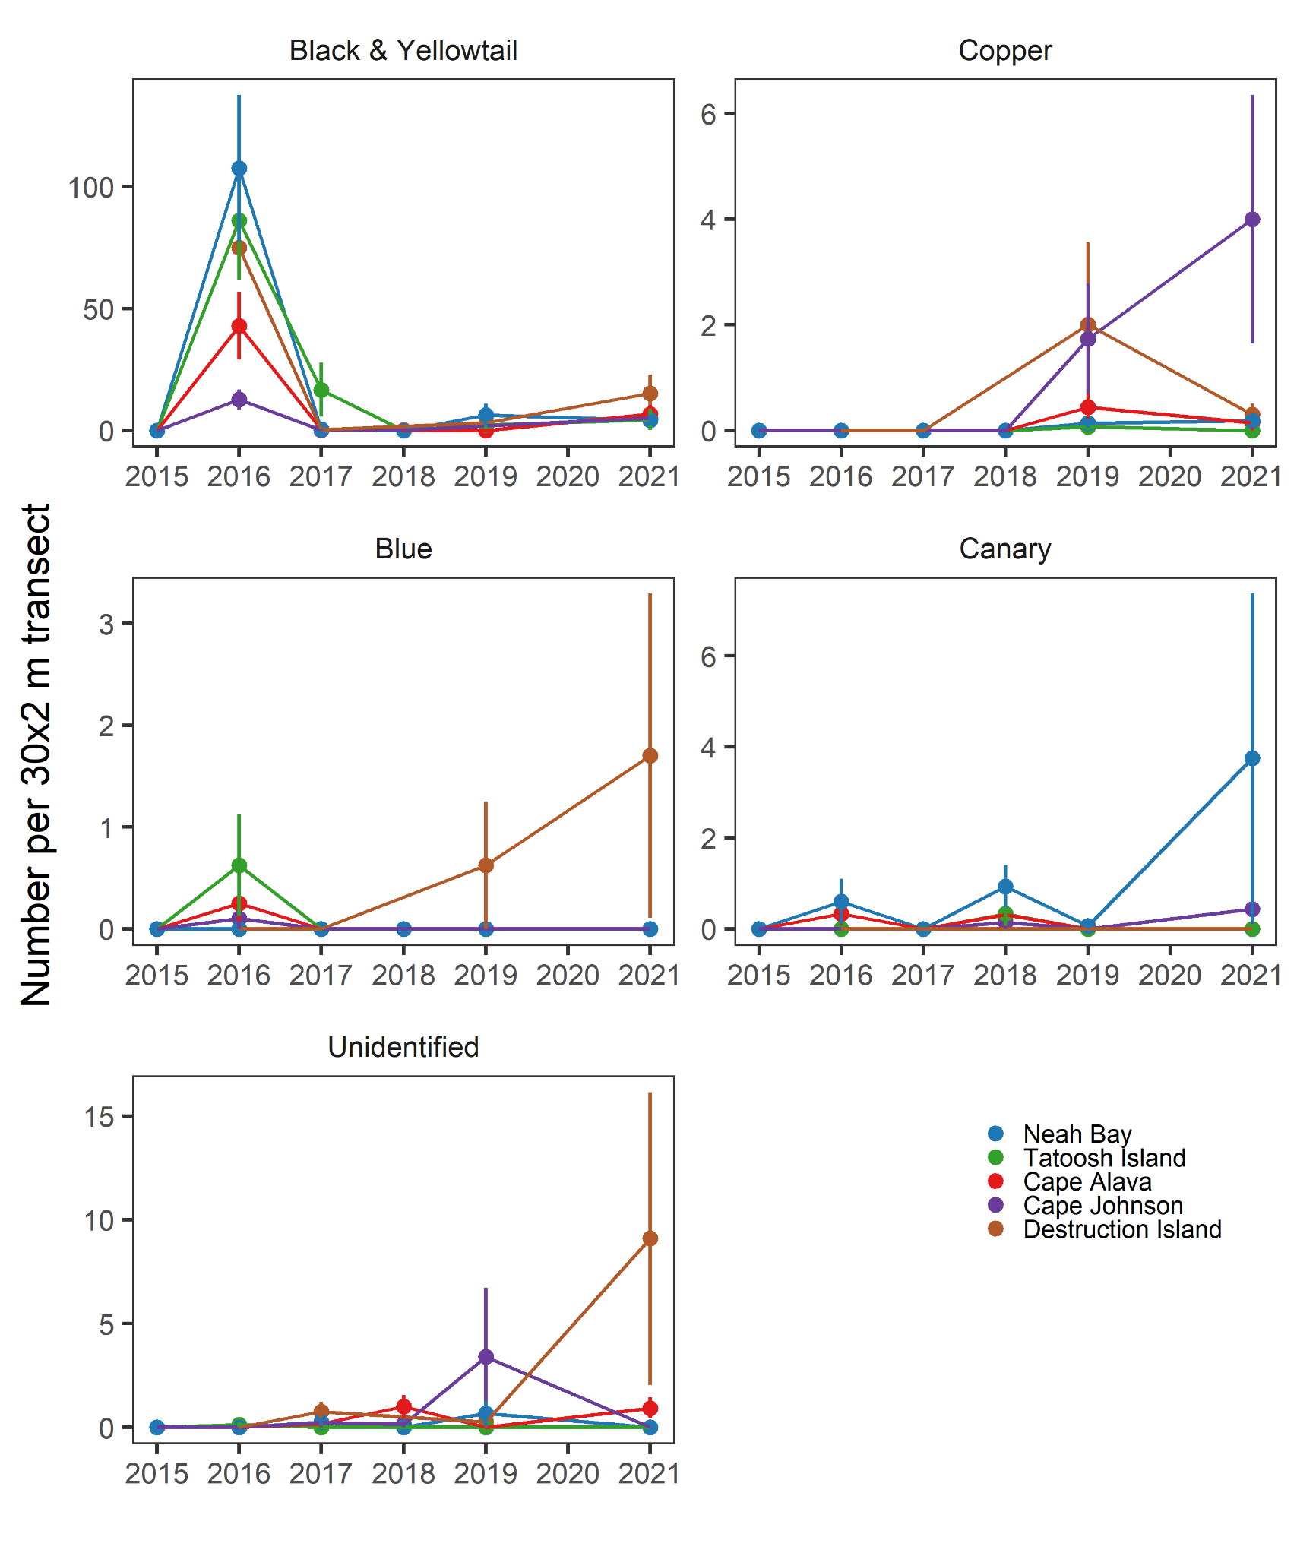

##### Figure S8. Abundance of rockfish young-of-year at five sites from 2015-2021. Note the scales on the y-axes differ.